

Final Report

1. Project name & Value Proposition 3

2. Team Sage 3

3. Problem/Solution Overview 4

4. Needfinding 5

5. POVs & Experience Prototypes 8

6. Design Evolution 16

7. Values in Design 45

8. Final Prototype Implementation 47

9. Reflection & Next Steps 52

# 

# 1. Project name & Value Proposition

Project Name:

Sage

Value Proposition:

Where gardening blooms into lasting friendships and vibrant living.

# 2. Team Sage

| **Adam Barry (BS ‘25)**  User Researcher, Web/Mobile Developer | **Amy Chang (BS ‘25)**  Roles: User Researcher, UX Designer |
| --- | --- |
| **Brendan McLaughlin (BS ‘24)**  Roles: User Researcher, UX Designer, Mobile Developer | **Ethan Hellman (BS, MS ‘24)**  Roles: User Researcher, Product Manager |

# 3. Problem/Solution Overview

Oftentimes, elderly individuals can face challenges in maintaining active engagement with their communities, leading to feelings of loneliness and a diminished sense of purpose. Sage seeks to address this issue by establishing gardening groups to foster new friendships and a sense of purpose through simplified group formation, scheduling, and location logistics. Beyond merely organizing gardening activities, Sage nurtures a culture of mutual care and compassion, encouraging members to actively support each other. This creates a community where each individual's presence is valued and contributes to a larger, fulfilling endeavor centered around healthy, stress-free physical activity.

# 

# 4. Needfinding

In our need-finding journey across the Bay Area, we engaged with six individuals, all above the age of 67, navigating various stages of retirement. Our approach was organic and intentional, starting from local libraries and community centers, which yielded a rich array of willing participants for our study. Each interview involved meeting our participants exactly as they were. For most, that meant engaging with them as they engaged in whatever activity they were doing: knitting, staffing the front desk, doing a puzzle, etc. Our approach was simple: we kindly introduced ourselves and told them how we were conducting research for a class project to explore questions of fulfillment in the lives of elderly individuals and retirees. All participants were more than willing to engage in a short interview which, more often than not, extended well beyond 30 minutes.

Central to our inquiry was the question, “What does an active and fulfilling lifestyle mean to you?” This query unveiled diverse and poignant insights, particularly from Mary-Lue, whose experiences encapsulated the underlying issue of our project: the struggle for the elderly to engage actively with their communities and combat loneliness and a diminishing sense of purpose.

Gail, a retired university professor, had shared her journey into the world of art and ceramics, finding them a source of deep fulfillment after her retirement. “Art is therapeutic. Ceramics fed my soul post-pandemic,” she had reflected. However, her transition from a structured academic career to retirement revealed a gap in community engagement and purpose. Gail’s experiences highlighted the need for meaningful activities that extended beyond individual hobbies, offering opportunities for social interaction and community belonging.

Mary-Lue mentioned how she actively manages her business and passionately advocates for engagement beyond traditional retirement activities. “People need something to do other than watch TV all day,” she had emphasized, underscoring the importance of maintaining an active lifestyle. Her belief that “being involved is central to a fulfilling lifestyle,” and the importance of having loved ones around, spoke volumes about the vital role of community and social connections in creating a fulfilling life in retirement.

Anita had expressed enthusiasm for new experiences, saying, “People can and still want to do new things,” highlighting the ongoing desire among seniors to learn and grow. She also touched on the vulnerabilities faced by seniors, such as falling prey to scams, which underscored the importance of a supportive and vigilant community network.

Marie provided valuable insights into the significance of maintaining a balanced lifestyle, focusing on both mental and physical health. “Mindfulness is important, nutrition is important and hard,” she had remarked, pointing to the challenges of sustaining a health-focused routine, a struggle many seniors face in their daily lives.

Robin's story was particularly moving. Coping with the loss of family members and the challenges brought by the pandemic, she spoke of her need for change and connection: “I might be ready for a lifestyle change once I am more emotionally settled from these losses.” Her visits to the library to see and sometimes talk to people illustrated her search for social interaction and her yearning for a sense of normalcy and joy, “My goal now is to enjoy my days.”

A standout interaction was with Bill, conducted remotely, which provided a contrasting perspective to the in-person discussions we had with Gail, Mary-Lue, Robin, Marie, and Anita. Bill, sharing his practical approach to staying active, had said, “Having to walk my dog is one of the things that gets me to walk.” He acknowledged the benefits of being outdoors and the importance of safety, “It feels good to get outside and walk. I just have to be safe on the hills.” His perspective reflected a common sentiment among many seniors: the need for accessible and enjoyable physical activities integrated into their daily routines.

Together, these narratives helped paint a rich tapestry of the elderly experience, highlighting the individual and collective struggles to stay engaged, connected, and active. They underscore the diverse ways individuals confront and adapt to the realities of growing older, each carving out their path to fulfillment and community in their twilight years.

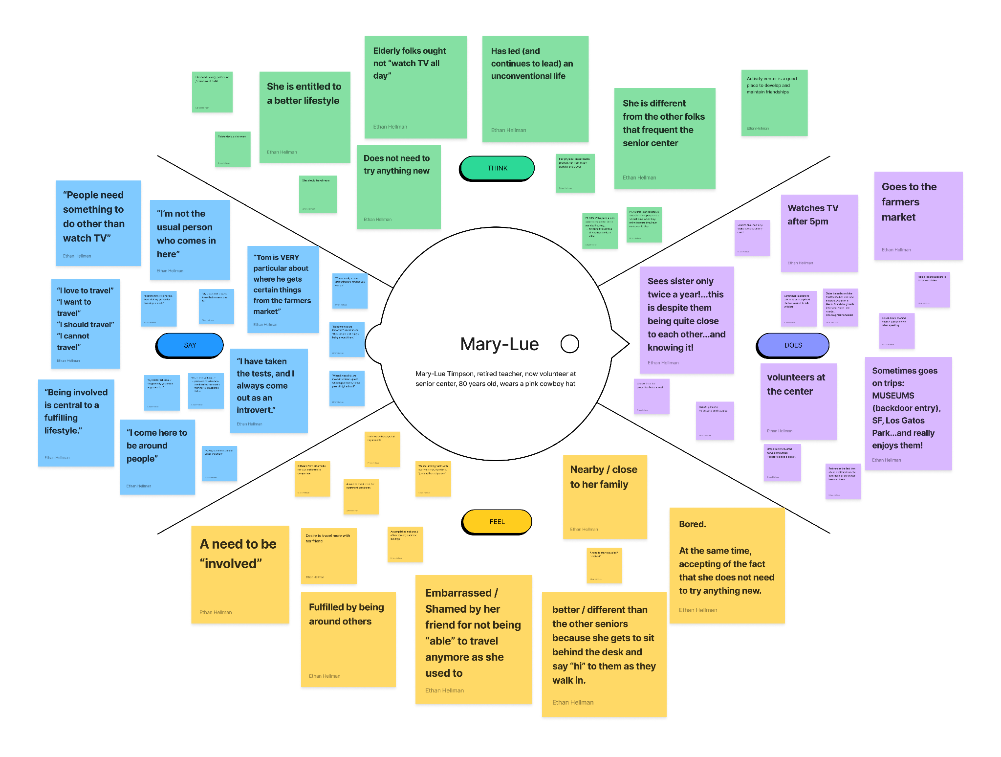

*Figure 1. Mary-Lue Stinson Empathy Map*

Throughout our comprehensive interview process with retirees in the Bay Area, we constructed unique empathy maps for each participant (ref. Figure 1). This methodical approach involved at least two team members per interview—one leading the conversation and another dedicated to taking detailed notes. These notes were invaluable, as they enabled us to distill key observations from each discussion into a comprehensive and presentable format.

The synthesis of these individual empathy maps led to various forms of analysis, key insights, and learnings. As we delved into the emotional landscape of aging, we focused particularly on the feelings of disconnection and the challenges associated with maintaining an active lifestyle. Our interviews revealed profound insights into the habits and routines of those in their retirement years.

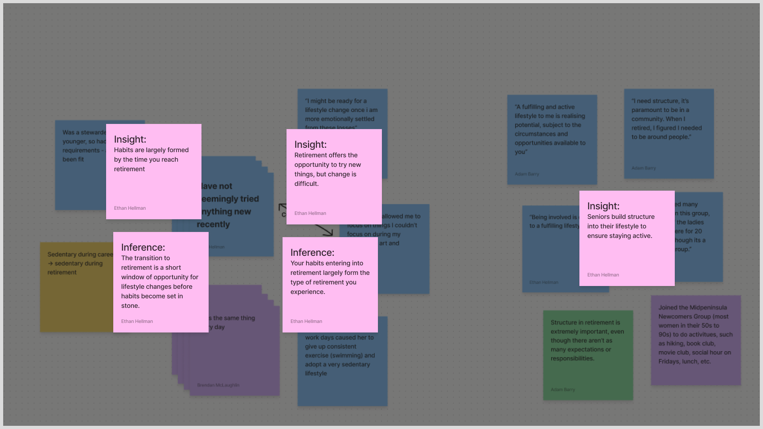

*Figure 2. Analysis & Synthesis of Needfinding Insights*

We inferred (ref. Figure 2) that habits are largely formed by the time one reaches retirement, highlighting the transition to retirement as a crucial window for lifestyle changes. This insight suggests that before habits become set in stone, there is an opportunity for significant adjustments, which can dramatically impact the quality of one's retirement.

Furthermore, we observed that seniors often construct a structured lifestyle to ensure they remain active. This finding led us to understand that the habits formed as one enters retirement largely dictate the nature of their retirement experience. It emphasizes the importance of developing healthy routines and activities prior to retirement, as these can form the foundation of one's later years.

Additionally, we recognized that retirement presents opportunities to try new things, but change can be difficult once routines are established. The key insight here is the importance of initiating habit changes and exploring new activities early into retirement before the daily routine becomes too rigid. This phase, while offering newfound freedom, also requires guidance and encouragement to embrace change and new experiences.

Overall, these insights helped underscore the complexity of transitioning into retirement. They highlighted the need for supportive structures that encourage early habit formation, activity engagement, and the exploration of new interests among retirees. This understanding would prove crucial in designing programs and activities that cater effectively to the unique needs of this demographic and helping them navigate this significant life stage with fulfillment and purpose.

# 5. POVs & Experience Prototypes

Following our needfinding process, we honed in on three particularly enlightening interviews to spark our solution brainstorming. Our approach began with crafting a Point-of-View (POV) statement for each interview. These POV statements serve as concise reframings of the problems, based on unique user needs and insights. They comprise four elements: the individual we encountered, an unexpected observation from the interview, a hypothesis derived from this observation, and a pivotal insight that could potentially be a 'game-changer' in developing a solution. For each of these game-changers, we generated 10-15 'How-Might-We' (HMW) statements. These HMWs were instrumental in delving deeper into how we could transform these critical insights from our POVs into actionable solutions. Following this, we identified the most viable and appealing HMW for each POV, brainstormed a list of solution to address the selected HMW, picked our favorite and most promising solution, and then crafted an experience prototype for each identified solution. This approach allowed us to rapidly assess the assumptions inherent in our initial solutions. Below, we outline our three POV statements, a selection of HMWs derived from each, our chosen solutions for the standout HMWs, and the experience prototypes developed for each solution.

Mary-Lue POV:

**We met:** Mary-Lue Timpson, an 80-year-old retired school teacher who now volunteers at the front desk of the Senior Center in Palo Alto.

**We were surprised to learn:** that Mary-Lue Timpson considers herself separate from the other seniors, verbally distinguishing herself by saying, “I’m not the usual type of person who comes in here.”

**We wonder if this means:** she considers herself different from other seniors because of her clear role in the community which gives her a greater sense of purpose.

**It would be game-changing if we:** could deliver a similar sense of purpose through responsibility to more people.

HMW’s Statements Inspired by Mary-Lue:

It would be game-changing if we: could deliver a similar sense of purpose through responsibility to more people.

1. How might we: create more opportunities for elderly individuals to help each other?
2. How might we: facilitate interdependence between elderly individuals to create a sense of equality?
3. How might we: help cultivate a sense of independence and self-sufficiency for elderly individuals?
4. How might we: create structure for elderly individuals in their everyday lives?
5. How might we: facilitate community events without them feeling “old”?
6. How might we: provide elderly people with explicit roles within their community?
7. How might we: expand the opportunities for the elderly in the community volunteering space?
8. How might we: create avenues for senior citizens to learn new skills?
9. How might we: create new avenues for senior citizens to feel needed by their community?
10. How might we: expand opportunities for senior citizens to get involved and feel purposeful within their local community?

Final HMW Statement Inspired by Mary-Lue:

How might we: expand opportunities for senior citizens to get involved with their local community to create purpose in their community?

Potential Solution Ideas for HMW Statement Inspired by Mary-Lue:

1. An app that helps senior citizens learn about volunteering opportunities.
2. Create partnerships between senior homes and volunteer organizations like soup kitchens to create better pipelines for volunteering opportunities.
3. Have elderly citizens do more work with schools so as to get them to interact with younger individuals more.
4. Have elderly people help get younger individuals registered to vote...participation in democracy!
5. Leverage affinity for gardening to help maintain public parks - ie. plant trees, maintain gardens, etc. through community-based landscaping
6. Leverage participation in religious organizations to supplement learning for younger kids.
7. A platform whereby elderly citizens can volunteer for particular causes that interest them.
8. A space where elderly citizens can offer their services freely to individuals who seek those services e.g. asking for a knitted jumper, ceramics, baking, mechanical expertise, etc
9. Connecting elderly citizens to those who are less fortunate and allowing them to provide services, help them with certain things, etc.
10. Helping elderly citizens host yard sales or events that give them a purpose to clean out their house (my granny is a hoarder so this would be great for her).

Final Solution Inspired by Mary-Lue:

Leverage affinity for gardening activity to help maintain public parks - ie. plant trees, maintain gardens, etc. through community-based landscaping.

Critical Assumption to Test:

People would feel safe and comfortable gardening in public.

Experience Prototype Description:

To test whether people would feel comfortable gardening in public and around others, we sought out new participants by going to a local park. Prepared with a small collection of plants and a gardening tool (spade), we approached individuals much in the same way we recruited our need-finding participants. To our pleasant surprise, we were able to recruit multiple participants who were interested in our study. Leo, Roy, Thomas, and Kamillia were four people willing to participate who were of a diverse range in sex, ethnicity, and age. The experiment was simple: introduce the subjects to ourselves, the class and the problem statement, ask about their history of gardening, offer them the necessary supplies to plant a plant right then and there in the park, observe their response, and follow up with a set of questions afterward. Some of the questions included:

* Why did you / did you not feel comfortable planting in public?
* What are some of your primary concerns when gardening in public?
* What might encourage you to garden more often?

What Worked, What Did Not Work:

We observed some very interesting behaviors. While the majority of our participants (¾) were unwilling to plant in public, one participant, Kamilla, actually did. Overall, our participants responded quite enthusiastically to the idea but were simply uncomfortable engaging with the activity themselves. For Kamilla, the only one who did engage in the activity, the exercise elicited an immediate sense of community and attachment, exclaiming that she would “come back every day and water it!” Additionally, through all of our conversations, it was clear that service was a clear means of fulfillment for people. The concept of helping to maintain a public space and give back to the community was something that universally appealed to our participants.

What did not work in this prototype was indeed the fact that most people were not comfortable “defacing public property.” Moreover, the activity seemed “frivolous” to some as it was not thought through long-term. Who would come back to water the plant? Would it simply be left to die? Was this the right plant for this temperature and sun exposure? Interestingly, some participants did not “feel qualified” enough to be gardening. While these behaviors did not see many people actually put plants in the ground, they did show very interesting behaviors and insights that would eventually guide the rest of our project.

The experience prototype revealed that while there is enthusiasm for gardening as a communal and fulfilling activity, concerns about public space etiquette and a lack of confidence in gardening skills are significant barriers. An effective app would need to incorporate elements that foster a sense of belonging and community, provide clear guidelines on public space use, and offer educational resources or tutorials to empower users, regardless of their gardening experience level. These details would surely help create an inclusive and supportive digital environment that encourages more people to participate in community gardening activities.

Robin POV:

**We met:** Marie and Robin, one active, social, and positive retiree and one inactive, negative, and antisocial retiree.

**We were surprised to learn that:** they think their divergent career lifestyles characterized their divergent retirements.

**We wonder if this means:** there was a window of opportunity between their career and the start of retirement to form new healthy lifestyle habits.

**It would be game-changing if we:** could help new retirees capitalize on that window early to proactively ensure healthy and long retirements.

HMW Statements Inspired by Robin & Marie:

It would be game-changing to: help new retirees capitalize on that window early to proactively ensure healthy and long retirements.

1. How might we: encourage every new retiree try a new sport?
2. How might we: prevent people’s loved ones from passing?
3. How might we: ensure that young people are aware of the full consequences of their choices early in life?
4. How might we: connect seniors with foster pets?
5. How might we: ensure every senior always has someone… or something… to talk to whenever they need?
6. How might we: do speed dating for new retirees and hobbies?
7. How might we: make everyone develop the habit of an active and social lifestyle from a young age regardless of profession?
8. How might we: make young people choose hobbies and jobs that result in long-term active lifestyles in retirement?
9. How might we: replace people’s loved ones when they die?
10. How might we: make sure every senior has friends who are living active lifestyles?

Final HMW Statement Inspired by Robin:

How might we: ensure every senior always has someone or something to talk to whenever they need?

Potential Solution Ideas for HMW Statement Inspired by Robin:

1. An app with digital pets that older adults can take care of.
2. Establishing better connections with grandchildren by creating a game they can play together.
3. Location-based Tinder-esque retiree friend-finder.
4. Connect elderly people from across the globe so that they might meet people from different cultures.
5. A platform where senior citizens can join book clubs local to their communities, keep up reading with their group members, and meet up.
6. Rent a pet for a day.
7. A platform for anyone that wants to rant about something, elderly people can hop online to sit and listen...might be entertaining...never know what someone is going to say!
8. AI-chat bot that will talk to elderly citizens about things that they are interested in e.g. family, and sports.
9. An anonymous app where elderly people can tell stories from their youth.
10. A mentorship-based platform where elderly citizens can advise younger people on being successful in their respective careers.

Final Solution Inspired by Robin:

A platform where senior citizens can join book clubs local to their communities, keep up reading with their group members, and meet up.

Critical Assumption to Test:

Elderly people are excited about discussing books with their peers.

Experience Prototype Description:

To evaluate this hypothesis, we developed an experience prototype that simulated the process of organizing a reading group. We returned to the local library, where we recruited new participants, mirroring the approach used in our initial need-finding exercise. After a brief introduction about our class and the purpose of the exercise, we engaged participants in a conversation about their current reading interests. To gauge their enthusiasm for discussing books in a group setting, we provided them with paper to jot down their ideas for conducting a book club or discussion group. Follow-up questions were posed to further assess their excitement about such an endeavor. Some of the questions included:

* Do you feel more or less interested in creating/joining a book club/discussion group?
* What would excite you most about being in a book club?
* What are the most important aspects of a discussion group to you?

What Worked, What Did Not Work:

The experience prototype, despite a limited number of participants, successfully elicited valuable feedback from those engaged. We found that our participants, particularly one individual who was actively involved in multiple book clubs, were enthusiastic and forthcoming with their experiences. Their eagerness to share insights and suggestions for the potential platform indicated a genuine interest and a positive response toward the concept of a book club for senior citizens.

However, the prototype's effectiveness was somewhat diminished due to the expertise of our key participant. Being well-versed in book clubs, this individual focused more on offering suggestions for the platform rather than engaging with the prototype as intended. This skewed the experimental process, as we gathered more ideas for improvement rather than direct responses to the prototype's functionality and appeal.

The most significant learning from this prototype was the underlying value of the book club group itself, beyond the literary discussions. The regularity of meetings and the consistency of seeing familiar faces each week emerged as key elements of fulfillment for participants. This insight shifted our perspective, underscoring the importance of regular social interaction and community building for elderly individuals. It highlighted that the success of such a platform would hinge more on fostering a sense of community and consistent engagement rather than solely focusing on the literary content.

Marie POV:

**We met:** Marie: a 76-year-old former Stanford researcher who lives a very physically and socially active retirement lifestyle.

**We were surprised to learn:** that all of her friends also have active and social lifestyles.

**We wonder if this means:** that her friend group serves as a community that keeps her accountable and motivated to stay active and healthy.

**It would be game-changing if we:** could ensure that all retirees have supportive communities that facilitate and encourage healthy lifestyles.

HMW Statements Inspired by Marie:

It would be game-changing if we: could ensure that all retirees have supportive communities that facilitate and encourage healthy lifestyles.

1. How might we: help existing elderly friend groups stay accountable to one another?
2. How might we: help elderly people learn about opportunities in their area like joining social clubs, planning trips, or signing up for daily activities to add structure to their day?
3. How might we: create a way for elderly people to form new friendships and join friend groups?
4. How might we: connect more individuals interested in fitness in the elderly community?
5. How might we: make communal physical activity more appealing to those less socially inclined?
6. How might we: make those who work out together feel more like a team?
7. How might we: learn a team sport that is geared towards elderly people with less physical mobility and greater physical risk?
8. How might we: leverage telecommunications to connect elderly fitness peer groups separated by distance?
9. How might we: make fitness groups more accessible and inviting for elderly people?
10. How might we: make existing peer fitness groups more inviting to those elderly without a cohort?

Final HMW Statement Inspired by Marie:

How might we: learn a team sport that is geared towards elderly people with less physical mobility and greater physical risk?

Potential Solution Ideas for HMW Statement Inspired by Marie:

1. Create a new sport that is a little more chill than pickleball that the elderly can play together in their local community.
2. Create a global competition for [insert sport] designed for the elderly.
3. Sports betting for the elderly on TV sports OR pickleball OR new made-up sport.
4. Pickleball tournament for the elderly.
5. Community service hours competition for different senior homes.
6. Senior homes create competitive teams for bingo and then compete in regional/local tournaments with other senior homes.
7. Create a platform whereby elderly citizens can follow a local sports team (get involved with the community and stay active).
8. Retirement homes have certain leaderboards for things like miles walked every week that are then shared with everyone for them to compete
9. Elderly folks love puzzles! Have them do puzzle races/puzzles together
10. Create a platform whereby elderly citizens can host sports-based events and invite other elderly people to join.

Final Solution Inspired by Marie:

Create a platform whereby elderly citizens can follow a local sports team (get involved with the community and stay active).

Critical Assumption to Test:

Elderly citizens are interested in local sports.

Experience Prototype Description:

To evaluate whether elderly individuals were interested in following local sports teams, we conducted an experiment that involved showing participants highlights from local teams, such as the San Jose Sabercats, San Jose Barracuda, and SF Deltas. For recruitment, we visited a local park, targeting active elderly folks who might have an affinity for sports. Our approach mirrored our need-finding exercise, where we introduced ourselves and the project before showing the sports highlights. We observed and took qualitative notes on the participants' reactions during the viewing. Afterward, we asked a series of questions to gauge their experience and level of interest in "interacting" with local sports teams. Some of the questions included:

* How willing would you be to support a local sports team?
* How would supporting a local sports team make you feel?
* What would compel you to support a local sports team?

What Worked, What Did Not Work:

The participants generally responded positively to the videos of local youth sports teams. Most expressed a willingness to support a local team and pointed out existing communities or groups, like local high schools or sports-affiliated affinity groups, that could facilitate their support. This indicated a latent interest in community sports among elderly participants.

However, the experiment lacked a certain level of structure, making it challenging to gauge strong emotional responses to the videos. While participants verbally expressed support for local teams, their enthusiasm seemed tepid, with interest more in limited support roles rather than in active management or organization.

Despite some of the shortcomings, the prototype revealed crucial insights. It became evident that while elderly participants were keen on supporting their local community, they were hesitant about taking on any managerial or organizational roles. This finding aligns with a broader theme observed across our experiments: the elderly are attracted to the idea of being part of a community but are daunted by the prospect of organizing or leading one. This insight was vital for the development of our solution, emphasizing the need to facilitate community involvement while lowering the pressures of management and organization.

# 

# 6. Design Evolution

After careful consideration of the outcomes from our various experience prototypes, our team unanimously chose the gardening solution to pursue for our final project. This decision was informed by a series of insights highlighting the unique needs and preferences of the elderly community.

Our public gardening prototype uncovered a multifaceted relationship between the elderly and community activities. The participants showed a genuine enthusiasm for gardening, countered by apprehensions about altering public spaces. Kamilla's positive engagement in the gardening activity, however, was a revelation. Her sense of community and attachment to the activity demonstrated the profound impact such communal endeavors could have, guiding us to see the potential of community gardening. Her involvement underscored the need for clear guidelines and reassurances regarding the use of public spaces.

The book club formation prototype offered additional insights. Participants displayed a keen interest in joining book clubs, emphasizing their desire for social interaction over literary content. This preference for communal engagement over the specific nature of the activity mirrored the findings from our gardening prototype, further affirming the importance of social connections in communal activities.

Our exploration into supporting local sports teams also shed light on elderly participants' preferences. Like the previous prototypes, participants were enthusiastic about being part of a community but reluctant to take on leadership roles. This theme of preferring participation in community activities without the added pressure of management or organization was a consistent observation across all our prototypes.

Combining these insights, we concluded that a community gardening solution would best serve the elderly's interests. This solution not only aligns with their desire for communal involvement but also offers an avenue for physical activity, essential for maintaining health in old age. Our team was particularly drawn to this solution, finding a shared enthusiasm for creating a platform that fosters community, physical wellness, and a connection to nature. Our final solution is thus designed to encourage elderly citizens to engage in community gardening, providing a supportive environment where they can enjoy the dual benefits of physical activity and social interaction.

Guided by these rich insights, we arrived at our final solution, Sage - an application specifically tailored to engage an older user demographic seeking fulfillment and community connection. Sage is meticulously crafted with our target users in mind, those who are at or nearing retirement age (65+), offering them a platform to organize and maintain gardening groups. Recognizing gardening as an activity ripe with potential for fulfillment and a natural gathering point for community building, Sage focuses on the human aspect of these groups. It's not just about nurturing plants, but more importantly, about nurturing human connections and fostering a sense of belonging. In essence, Sage is more than just a gardening app; it's a conduit for meaningful community engagement, designed to bring people together, enabling them to find joy and purpose in the shared experience of gardening. Ultimately, this solution embodies our learnings from the prototypes and aligns with our vision of enhancing the lives of the elderly through communal and fulfilling activities.

## 

## Task Selection

Based on the intended core functionality and objectives of Sage, we identified the following key tasks for our app. These tasks range from simple, common activities that all users perform, to moderate tasks that require more engagement, and complex tasks that cater to users looking for a deeper experience.

### Task 1: Simple - Invite a Friend to Your Garden

Reflecting on the inspiring stories from our need-finding interviews, we recognized the power of 'paying it forward' within community circles. This insight greatly influenced our app’s feature for inviting new members to gardening groups. More than a mere invitation, this simple task symbolizes a chain of kindness, extending a sense of community and belonging, much like a good deed passed from one person to another. This feature not only facilitates community growth but also embodies inclusivity and warmth. While gardening groups typically have a stable size, the ability to expand is essential for nurturing community bonds. Each invitation is a chance to positively impact someone's life, creating a ripple effect of goodwill. In essence, this task is a tribute to the values of kindness and inclusivity. It's a crucial element in our app, empowering users to enrich their gardening circles and lives through meaningful acts of connection and community building.

### Task 2: Moderate - Find Out When and Where to Garden

A foundational task in Sage is enabling users to find out when and where to participate in gardening activities. This task is vital for bringing people together around gardening and is one of the most frequently used features in the app. Users can easily access information on the timing and location of their next gardening session, ensuring they are always up-to-date with group activities. While regular, consistent schedules may make this feature a routine check for most users, its importance is amplified whenever there are changes or updates to the group’s plans. This simple task, therefore, serves as the backbone of the app's functionality, ensuring users have the essential information they need to participate in their community gardening activities and something to look forward to on a regular cadence.

### Task 3: Complex - Distribute Harvested Food to the Community

For our initial complex task, we focused on driving user fulfillment through community service. The strongest testimonies of fulfillment in our interviews came from those engaged in volunteer work. To harness this sentiment, we implemented a task flow that encourages users to organize their gardening efforts around harvesting and donating their produce to local communities. This task involves coordinating with fellow garden members and managing the logistics of harvesting and donation. It taps into the users' desire to contribute meaningfully to their community, turning their gardening efforts into a form of public service. This complex task not only enriches the user experience but also aligns with Sage's overarching goal of fostering broader community engagement and fulfillment.

## Low-fi Prototyping

In the initial design phase of Sage, we focused on creating a series of sketches and storyboards, drawing inspiration from our needfinding and ideation sessions. These early drafts were pivotal in determining the key structure and user experience flow of our app. They allowed us to explore various interface options and rapidly iterate on our designs. Below is a selection of these sketches and storyboards, which played a crucial role in shaping the fundamental aspects of Sage and led to the development of our preliminary prototype.

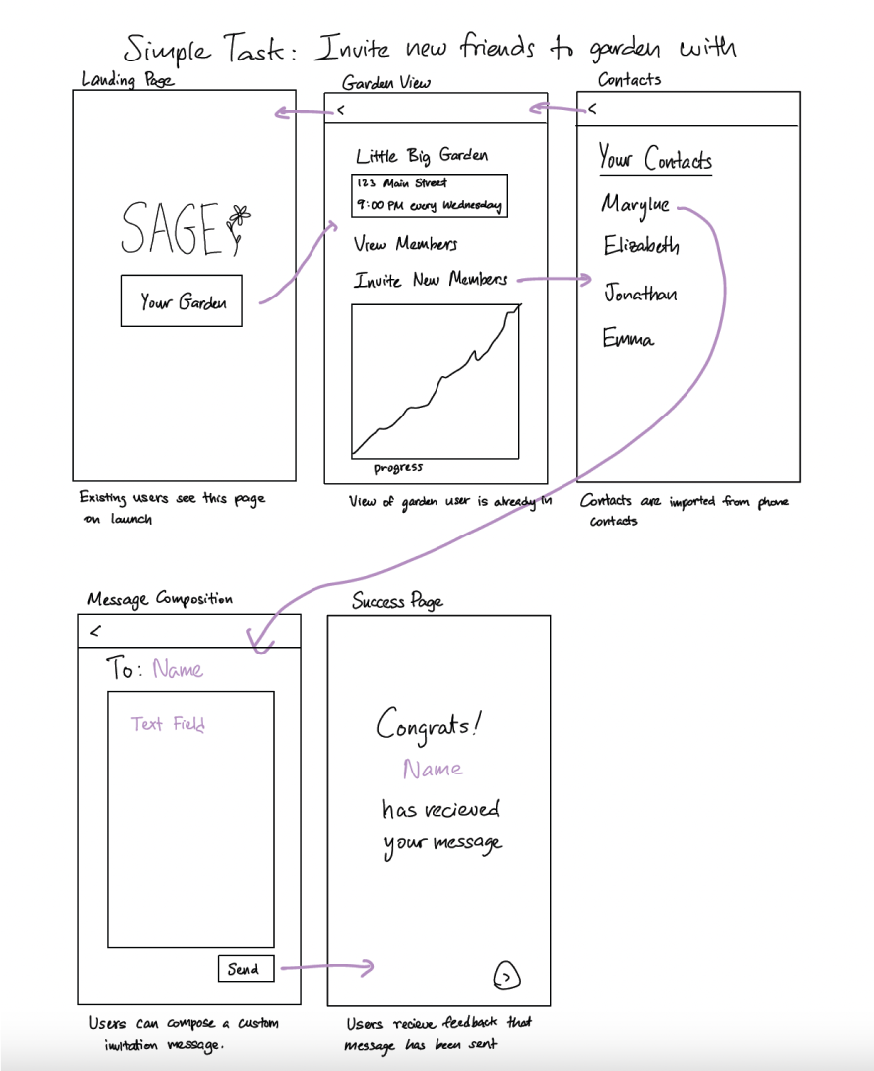

*Figure 3. App Storyboard for Simple Task Flow*

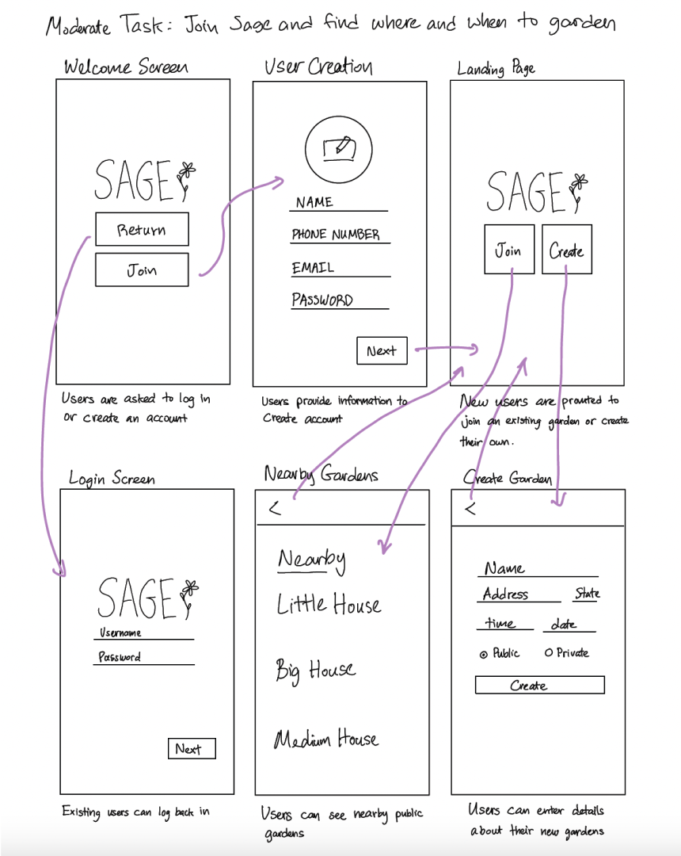

*Figure 4. App Storyboard for Moderate Task Flow*

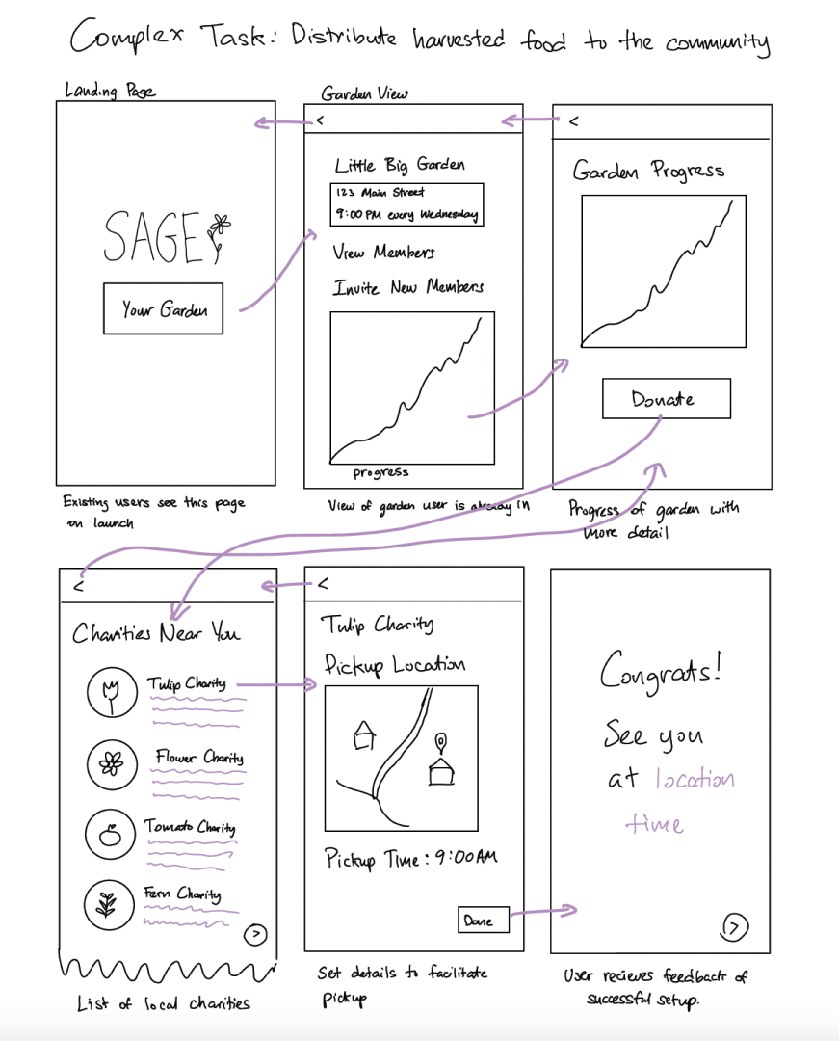

*Figure 5. App storyboard for complex task flow*

## Low-fi Prototype Creation

In developing our Low-fidelity prototype, we took a direct approach by creating hand-drawn screens on paper. This method allowed us to focus on our key tasks while intentionally excluding peripheral features like settings management, preference changes, etc. Our hand-drawn prototype was designed to be dynamic, with elements that could be filled out using either a pen or a dry-erase marker, making the dynamic components reusable.

The purpose of this approach was to ensure that our prototype stayed as basic as possible, which is crucial for eliciting high-quality user testing feedback. By avoiding high-fidelity elements that might distract from the core functionalities, we were able to keep the user testing focused on the usability and flow of the app. The hand-drawn nature of the prototype brought an element of simplicity and directness, allowing us to rapidly iterate based on user feedback and refine the design to better meet the needs of our target user base.

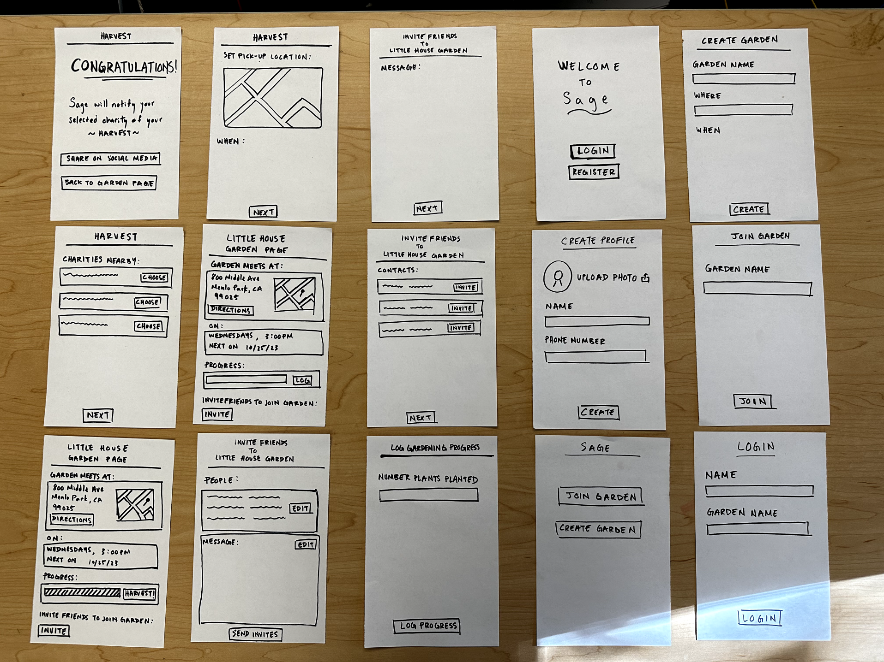

*Figure 6. Initial Low-fi Prototype*

## Low-fi Prototype: Usability Testing

### Methodology:

To refine the usability of Sage, we conducted in-person tests at the Little House community center, engaging with a varied group of participants. This approach provided us with direct and meaningful interactions, particularly valuable for our target demographic of older users.

Our usability testing focused on several key goals and metrics:

1. Ease of Learning: We evaluated how quickly new users could navigate basic app features like login and registration. This involved timing their first attempts and observing their success rates.
2. Efficiency of Use: We assessed the app's design for its ability to facilitate timely task completion, tracking the average time and steps needed to perform routine tasks.
3. Error Rate and Severity: Our goal was to ensure a low error rate during app usage, with errors being non-catastrophic and easily recoverable. We monitored the types and frequencies of errors and the time taken to recover from them.
4. Satisfaction: Direct feedback from users was collected to assess overall satisfaction with the app.
5. Accessibility: It was crucial to test the app's usability across various age groups and abilities, ensuring it was accessible and user-friendly for everyone.

During each session, participants were encouraged to practice the 'think out loud' method. This technique allowed them to verbalize their thoughts and actions as they navigated the app, providing us with real-time insights into their experiences, challenges, and points of satisfaction or confusion.

The sessions began with an introduction where we provided context about our class assignment, fostering a comfortable environment for feedback. Participants were then guided through the app's key tasks. Their spontaneous reactions and comments were invaluable in understanding user interactions and experiences with Sage.

This methodology enabled us to gather critical data to enhance Sage's design, ensuring it is intuitive and meets the needs of its diverse user base, with a particular focus on simplicity and ease of use for our elderly audience.

### Results:

Our usability testing, while not yielding extensive quantitative data, provided crucial qualitative insights, especially in understanding user interaction with our Low-fidelity prototype and identifying areas for improvement.

Login Flow and Design Patterns: A significant observation was the users' difficulty with the login process. Our deviation from common design patterns in this task flow contributed to confusion. Participants, particularly those accustomed to standard login interfaces, found our unique approach disorienting. This highlighted the need for balancing innovation with familiarity in design to enhance user navigation and comfort.

Engagement and Enjoyment: Feedback indicated that the app's overall appeal needed a boost in excitement. The most positively received aspect was the "congratulations" page, suggesting that elements of surprise or delight resonate well with users. However, other parts of the app lacked this engaging element, underscoring the importance of incorporating enjoyable and interactive features throughout to maintain user interest.

Full-Sentence Instructions for Accessibility: The testing revealed a need for more explicit guidance in the form of full-sentence instructions. This was particularly evident among participants who were less tech-savvy or had limited exposure to digital applications. Clearer, more detailed instructions would likely enhance the app’s accessibility and ease of use, especially for older users.

Error Encounters and User Confusion: A notable finding was the frequent occurrence of errors and confusion during the testing, particularly with the use of unconventional interactive components like dry-erase markers and pens for manual input. These errors were more prevalent among older participants, pointing towards a need for more intuitive design and clearer instructions. The confusion surrounding these dynamic components suggested that while innovative, they might not have been the most user-friendly or self-explanatory, emphasizing the need for a design that is both creative and intuitive.

Accessibility and Demographic Differences: The testing sessions with older users highlighted significant challenges in accessibility. These users encountered more errors and expressed higher levels of confusion compared to younger participants. This disparity emphasized the necessity to focus on making the app more accessible and user-friendly for all age groups, ensuring that design choices cater to a wider demographic range, especially considering our target audience.

Moreover, we specifically asked participants to complete three key tasks: inviting friends to the garden, logging in and finding out when and where to garden, and organizing their harvest/donation. Our observations revealed varying degrees of success and areas of confusion across these tasks.

### Task 1: Simple - Invite a Friend to Your Garden

Several participants experienced confusion around how to invite others to join their garden. While the concept was clear, the actual execution within the app was not as intuitive as we had hoped. Some users were unsure where to find the invitation feature or how to use it effectively.

### Task 2: Moderate - Find Out When and Where to Garden

The login process presented significant challenges for most participants. Users like Mollie and Caitlin were unclear about the steps involved, especially when it came to joining a garden for the first time. This confusion impacted their ability to efficiently access information about gardening times and locations, a crucial aspect of the app. Despite successfully logging in, some users were unsure where to navigate next to find this essential information.

### Task 3: Complex - Distribute Harvested Food to the Community

When it came to organizing the harvest and planning donations, participants again faced hurdles. The task was not perceived as intuitive or particularly useful in its current form. Users like Corliss suggested that this aspect of the app should be more celebratory, indicating a need for a more engaging user experience.

Overall, while all participants were eventually able to complete the tasks, the process highlighted several areas where the app's design could be optimized for better user experience. Participants found some aspects of the app, like the congratulations page and directions feature, positive. However, the difficulties with the login flow, tracking garden progress, and inviting others suggest that these areas require significant improvements to make Sage more user-friendly and intuitive.

## Results: Strengths and Weaknesses

The usability tests of Sage provided crucial insights into both the app's strengths and areas needing improvement, particularly in the harvest task flow.

### 

### Strengths:

The concept of Sage as a community gardening tool was well-received by most participants. Features that facilitated easy connection with the gardening community, such as inviting friends and locating gardening events, were considered intuitive and beneficial. Participants appreciated the app’s potential in enhancing their gardening experience and fostering community interaction.

### Weaknesses:

However, significant weaknesses emerged, especially in the harvest task flow. Participants demonstrated a lack of interest and confusion regarding the harvest and donation organizing feature. This indicated that the feature did not resonate with users and failed to communicate its intended value.

In addition, there was considerable difficulty in understanding how to track garden progress, with users unclear on how to effectively use this feature. The login process also presented challenges, particularly for first-time users who found it confusing and not straightforward.

The tests highlighted a need for a “higher-energy” design, with improvements to the calendar and time features, and simplifications in the login and create/join process. The feedback suggested that an increased emphasis on community aspects could make the app more appealing.

Implications and Future Focus:

These results imply that Sage needs to more clearly communicate its value, particularly for encouraging repeat usage. The difficulty in understanding certain features, like garden progress tracking, underscores the need for a design that is more intuitive and engaging.

### 

### Changes Planned:

In response, we plan to redesign Sage with a more vibrant and interactive approach. This includes refining the calendar and time features, streamlining the login process, and making the create/join process more user-friendly.

### 

### Unrevealed Aspects:

Our testing did not capture long-term app usage patterns or the ease of communicating with third parties, such as charities. Additionally, measuring the 'fun' aspect of the app remains a challenge, which we aim to address in future iterations.

These findings helped guide our next steps in evolving Sage, focusing on enhancing the user experience, especially in community engagement and garden progress tracking, to ensure the app is both enjoyable and valuable to our users.

## Major Design Changes: Low-fi Prototype to Medium-Fi Prototype

As we progressed from the Low-fi to the Medium-fi prototype of Sage, our design changes were carefully aligned with the underlying values of fostering purpose and friendships through gardening, directly addressing the needs of elderly individuals seeking community and meaningful engagement. Our major design changes consisted of the following:

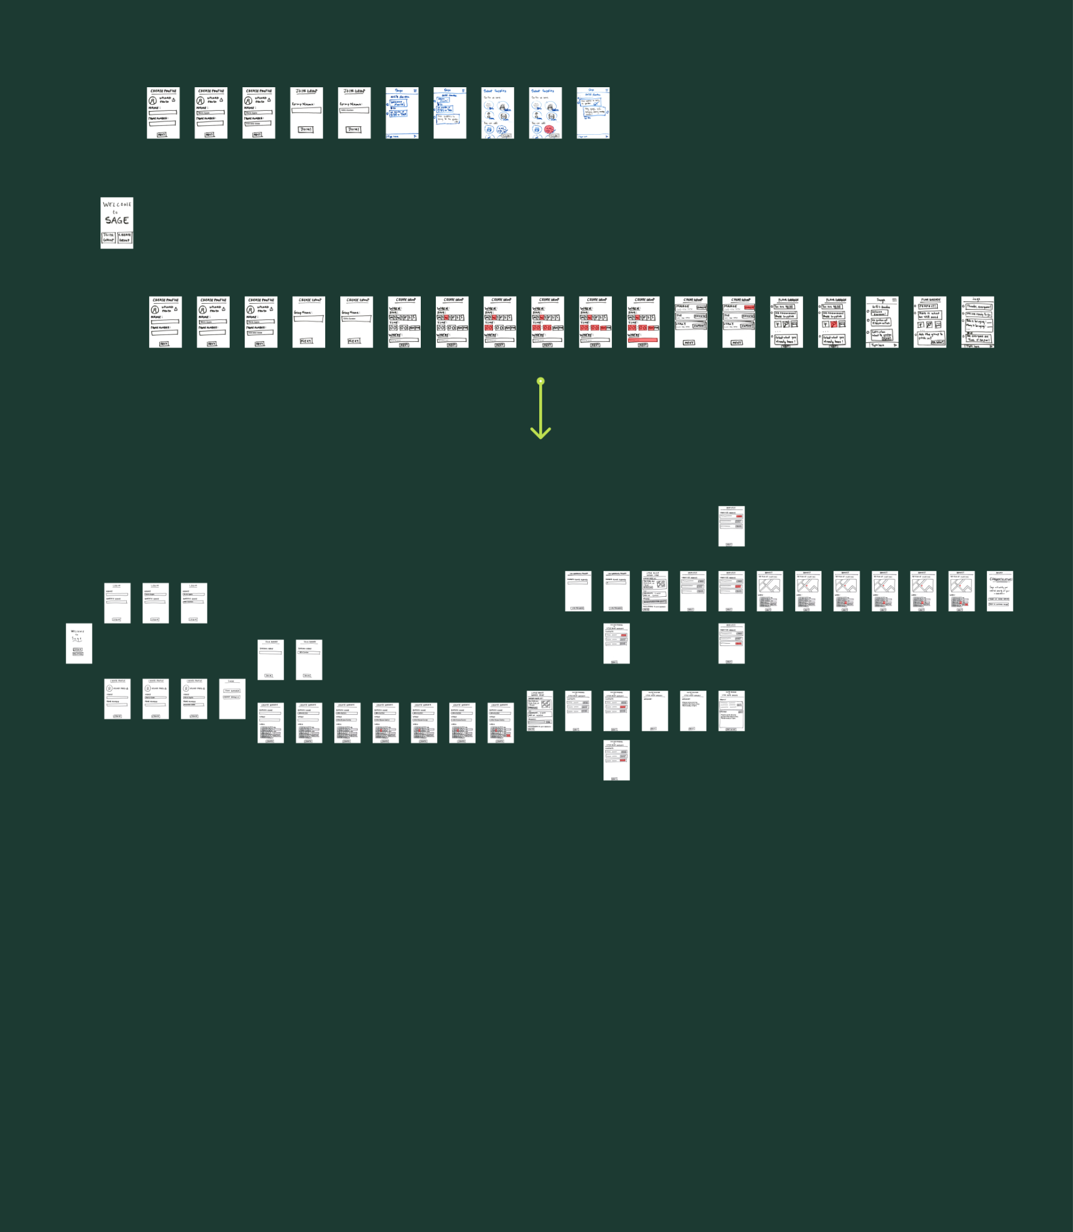

*Figure 7. Overall Low-fi Prototype Changes*

### 

### 

### 

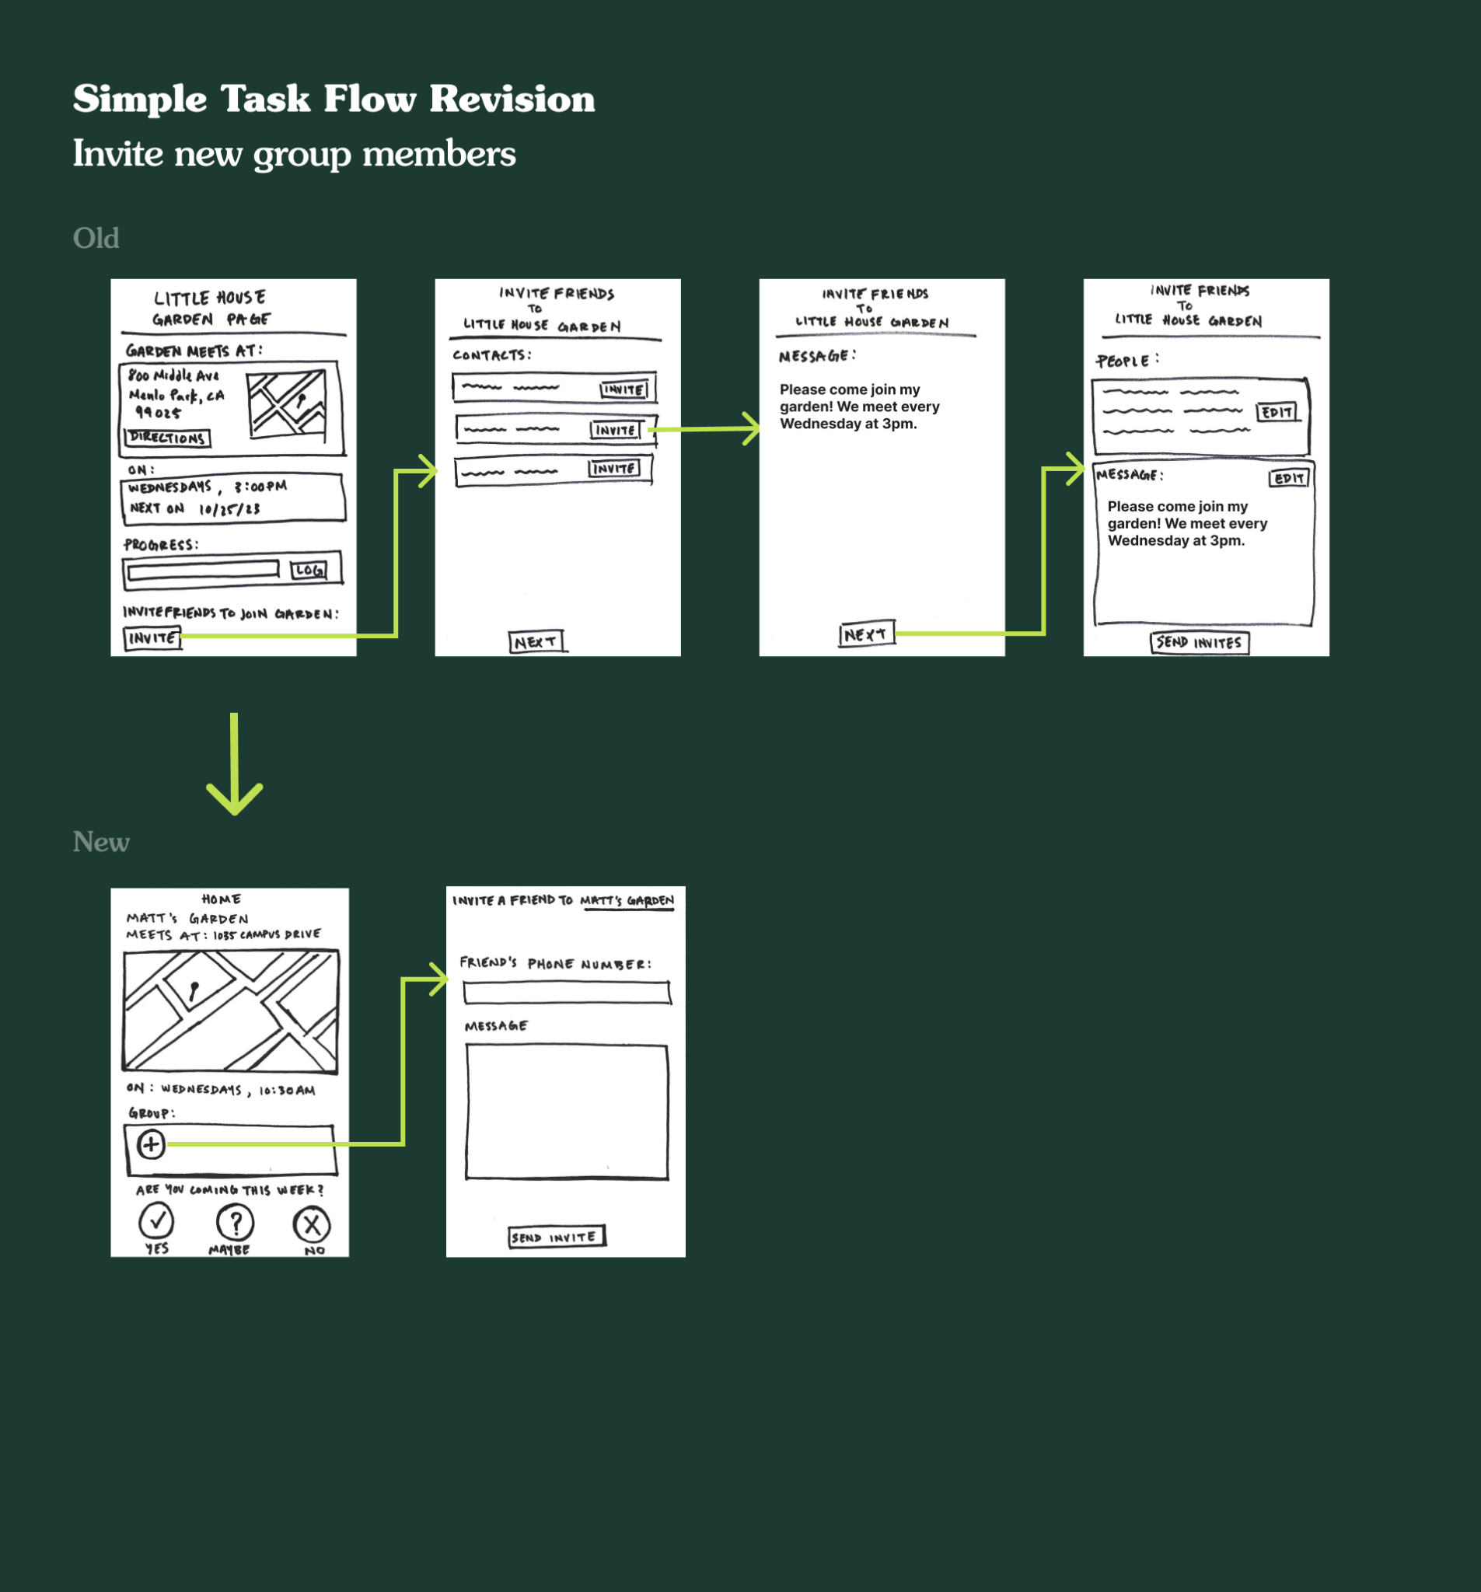

*Figure 8. Simple Task Flow Revisions*

### 1. Simplified 'Invite New Members' Process

Reflecting our commitment to creating community connections, we streamlined the process for inviting new members. By making this feature more accessible and user-friendly, we aimed to encourage users to expand their gardening groups easily. This change not only enhances user experience but also actively contributes to our goal of building vibrant, supportive communities where friendships can flourish.

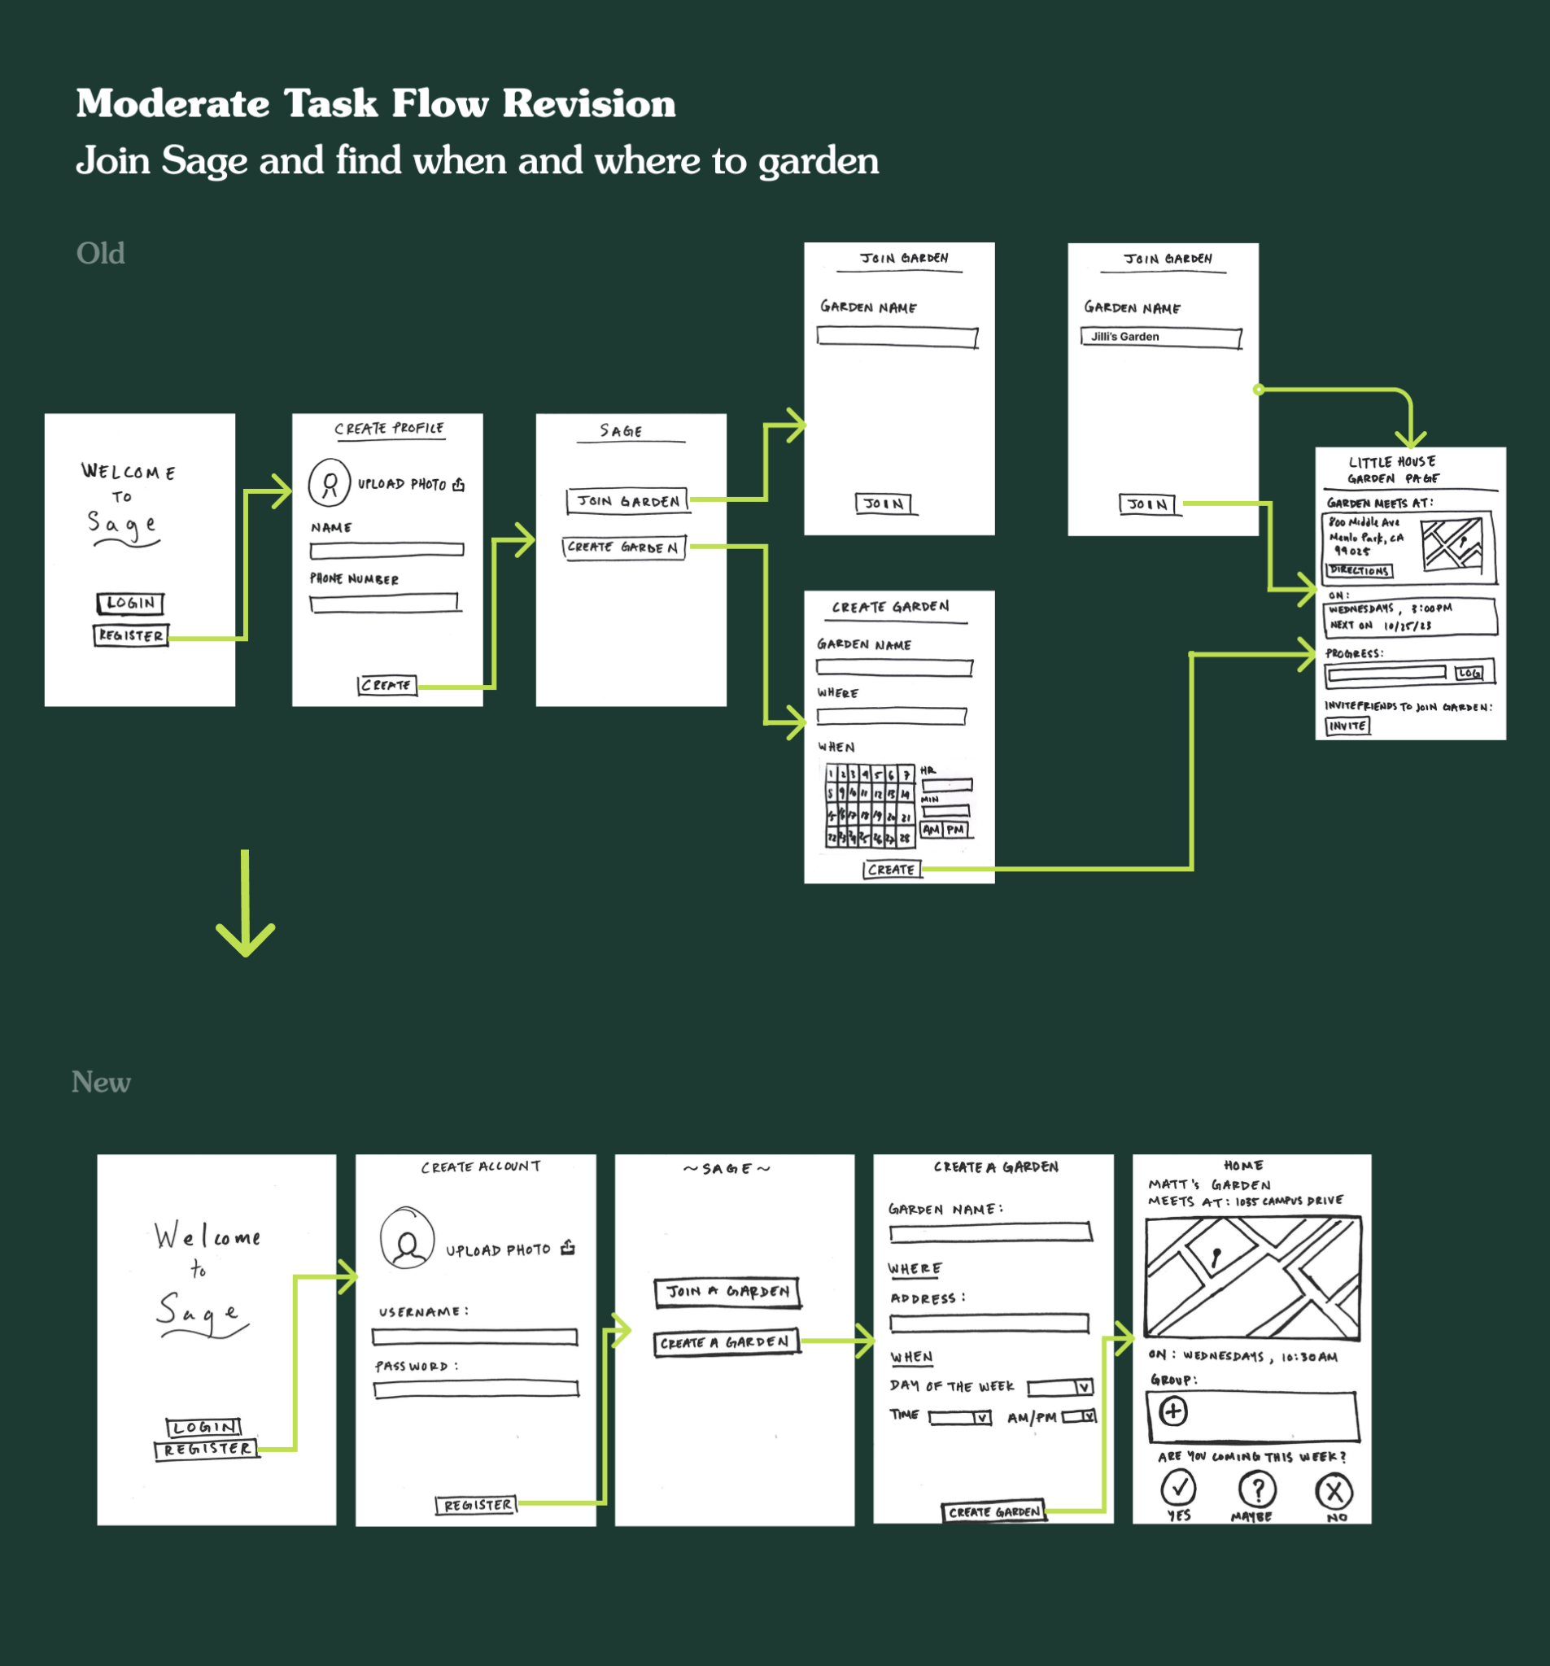

*Figure 9. Moderate Task Flow Revisions*

### 2. Streamlined Login and Onboarding Process

In our pursuit of extreme accessibility and simplicity, we overhauled the login and onboarding process. By creating a more intuitive and straightforward experience, especially for elderly users, we aimed to remove barriers to entry. This ensures that users can quickly engage in community gardening activities, fostering a sense of contribution and belonging right from the start by using a familiar design pattern.

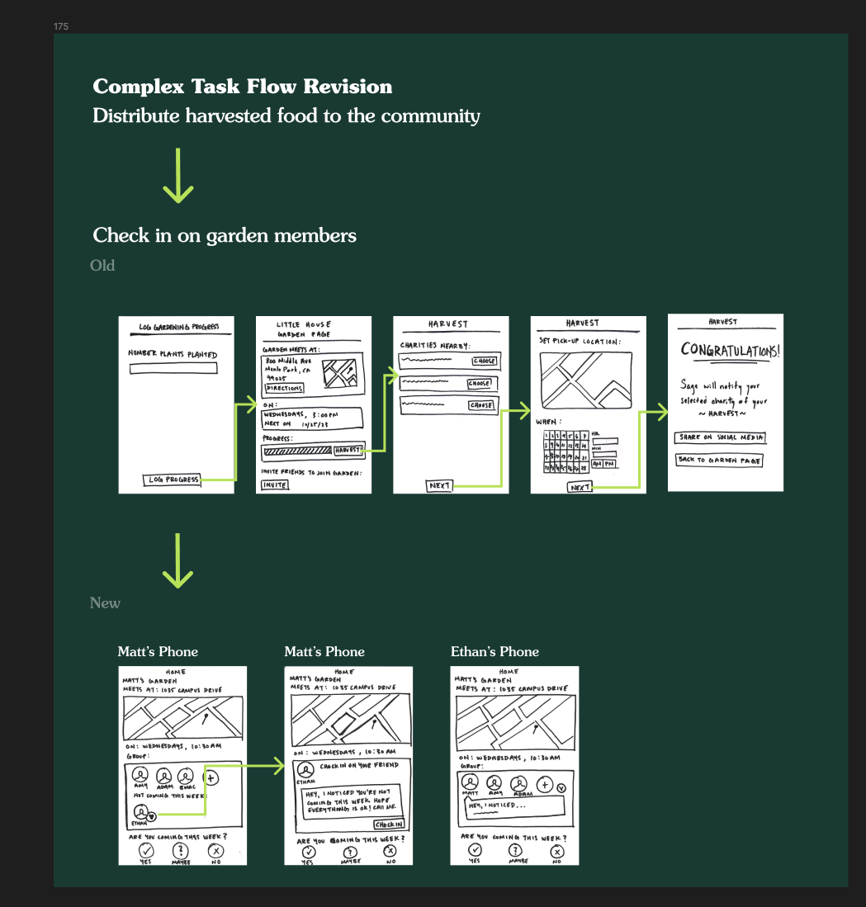

*Figure 10. Complex Task Flow Revisions*

### 3. Shift from Harvest to Check-In Task Flow

Aligning with the value of gentle accountability and our focus on human connections, we transformed the task flow to emphasize checking in on group members. This change not only simplifies the user interface but also deeply embeds the ethos of caring and support within the app, reinforcing the communal aspect of the gardening experience.

## Design Implementation in Figma

Utilizing Figma facilitated a collaborative and dynamic design process. This tool was instrumental in bringing these user-centric changes to life, enabling us to visualize and iteratively refine the app's functionality and appearance. The medium-fi prototype represented a significant stride towards our vision of providing elderly users the ability to reimagine their communal interactions, where gardening becomes a catalyst for building friendships and enriching lives.

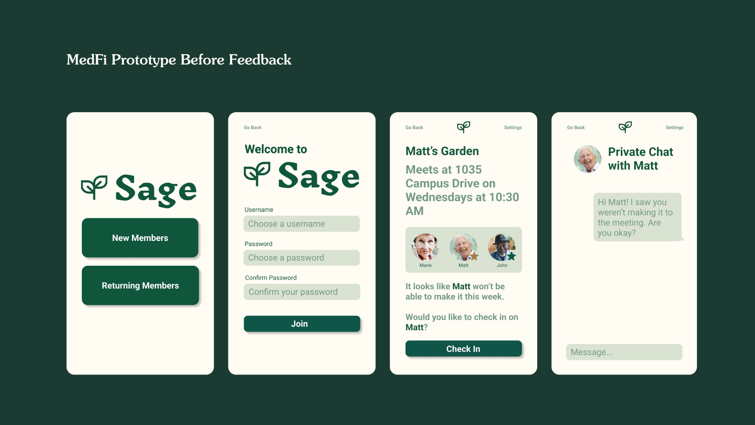

*Figure 11. Medium-Fi Prototype Initial Implementation*

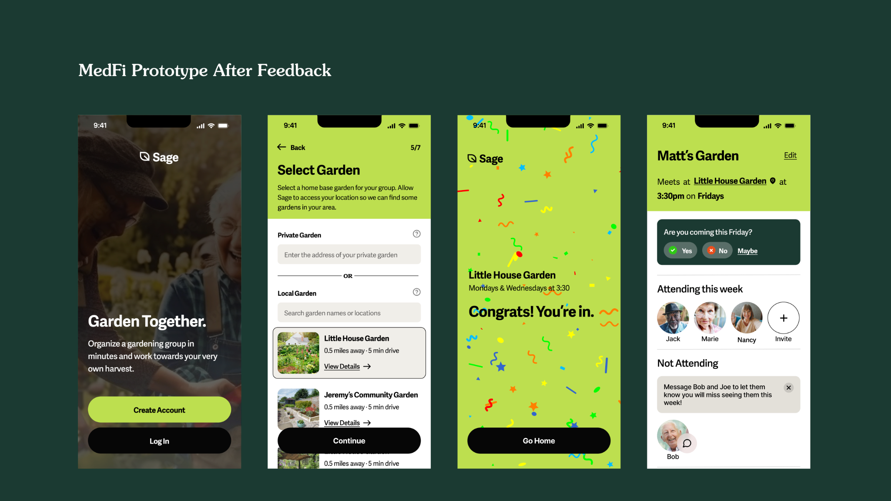

*Figure 12. Medium-Fi Prototype Secondary Implementation*

The transition from the first to the second design iteration of the Sage app marks a significant shift in user experience and visual communication. The first iteration offered a straightforward, text-based interface, focusing on functionality with a minimalistic approach. However, it lacked the warmth and engagement that community-centric apps benefit from.

In contrast, the second iteration introduces vibrant visuals and a more intuitive user interface. The "Garden Together" tagline instantly conveys the app’s purpose, fostering a sense of community and shared goals. The "Create Account" and "Log In" buttons are prominently displayed against an engaging background, providing a clear entry point for users.

The garden selection process has been significantly improved, presenting options for "Private Garden" or "Local Garden" with helpful prompts and a more appealing visual hierarchy that guides users through the setup process. This visual cue helps users understand the app's community-driven focus and the connection to their local environment.

The congratulatory page is now added back in, complete with celebratory graphics and a colorful design that rewards the user's successful action of joining a garden. This positive reinforcement is crucial for user retention and satisfaction.

Finally, the redesigned "Matt's Garden" screen exhibits clarity in attendance tracking. The use of familiar green, red, and amber colors for "Yes," "No," and "Maybe" provides an intuitive way for users to indicate their availability. The separation of attending and non-attending members, along with the invitation button and the ability to message absent members, enhances the social functionality of the app. The user’s own status is now clearly reflected, eliminating confusion about personal responses.

Overall, the second iteration is not just an aesthetic upgrade but a strategic enhancement of user interaction, promoting ease of use, community engagement, and a more personalized experience that resonates with the app’s core values of connection and active participation.

### 

### Med-fi Simple Task Implementation:

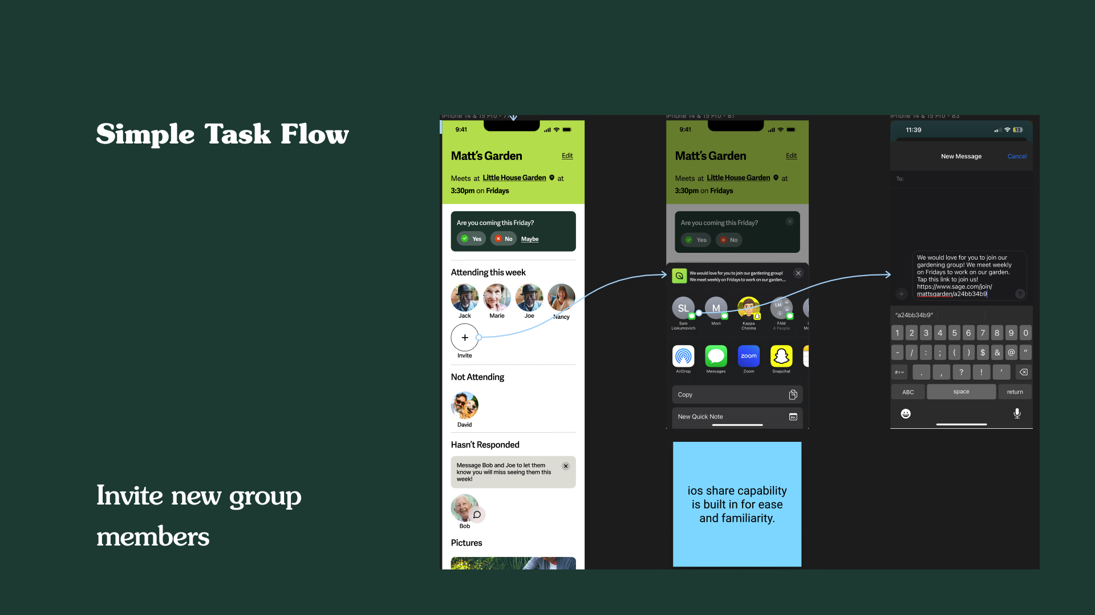

*Figure 13. Medium-Fi Implementation of Simple Task Flow*

For the "Simple Task Flow," inviting new group members is made effortless. The home screen of a garden provides all the necessary details about upcoming gatherings and integrates a seamless invitation process via familiar iOS sharing capabilities, catering to the users' comfort with known interfaces.

### Med-fi Moderate Task Implementation:

*Figure 14. Medium-Fi Implementation of Moderate Task Flow*

The "Moderate Task Flow" in Sage's prototype facilitates group engagement by guiding users through an intuitive login and group joining process. An invite word simplifies entry into existing gardening groups, while the creation of new groups is distilled into user-friendly steps. Once registration is complete, the home page contains all necessary information to attend the upcoming gardening group.

### Med-fi Complex Task Implementation:

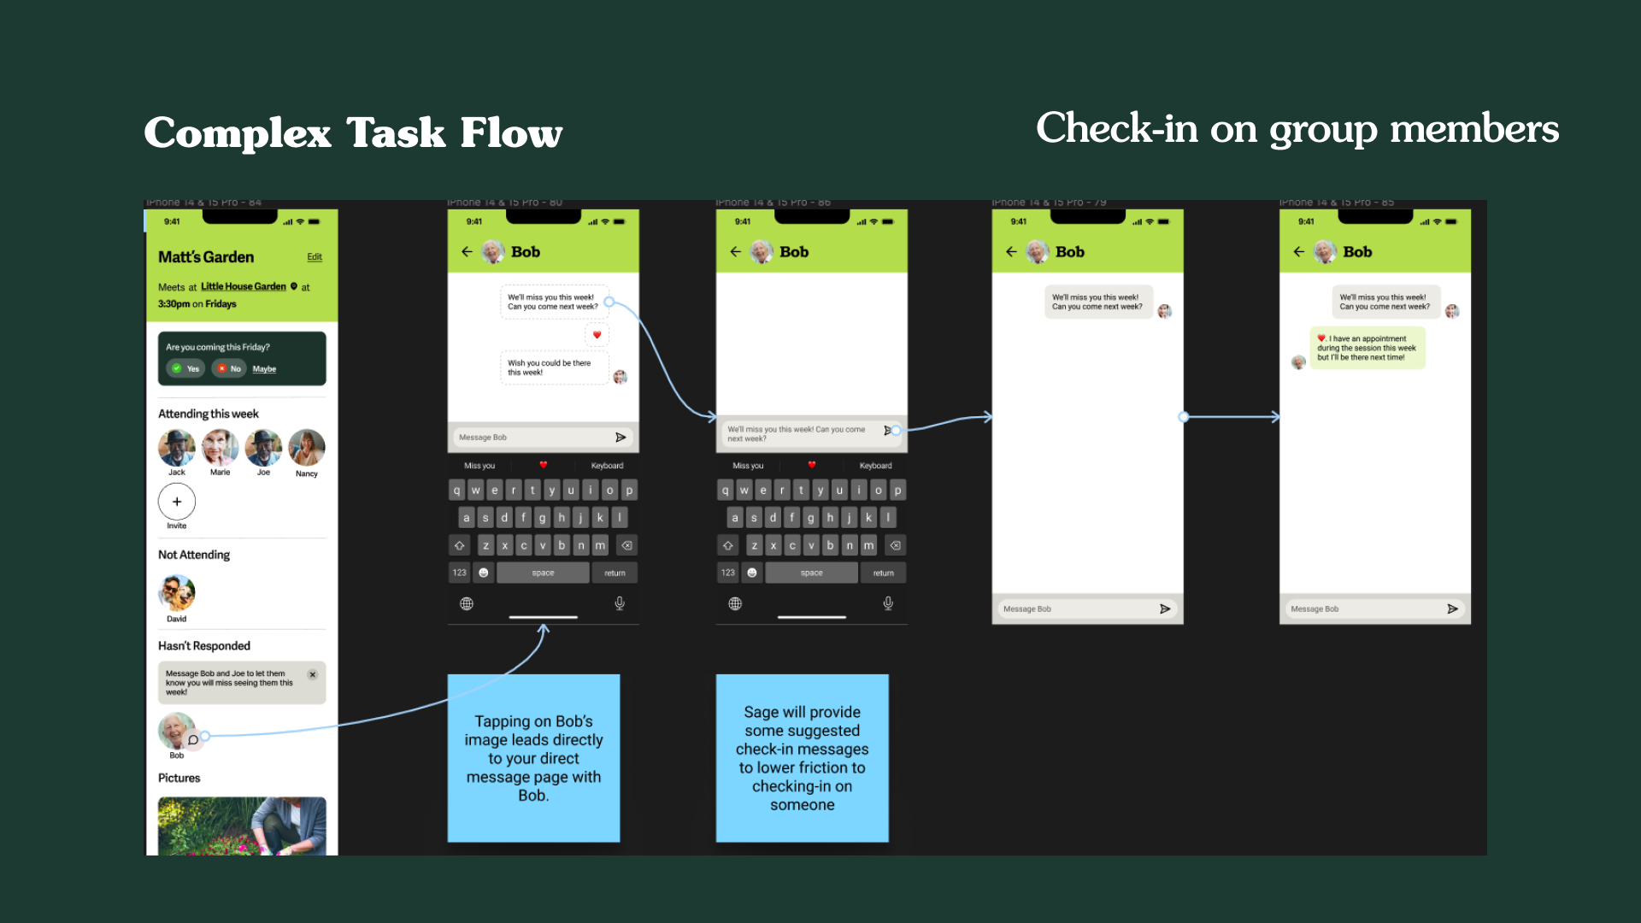

*Figure 15. Medium-Fi Implementation of Complex Task Flow*

The "Complex Task Flow" introduces a compassionate feature that allows users to check in on group members who are unable to attend the weekly garden meet. A direct messaging feature is incorporated, providing suggested check-in messages to encourage interaction and care within the community.

## 

## Addressing High-Severity Issues:

### Severity 4 Issues:

As we approached the final stages of our application development, our team undertook a meticulous evaluation of the feedback gathered from heuristic evaluations. This process was crucial in identifying and addressing key issues that could significantly impact user experience. Among these, three severity 4 issues stood out as critical to the app's functionality and user satisfaction. These issues were not just technical glitches but were deeply intertwined with the core experience and values that our application aimed to deliver.

## 

*Figure 16. Addressing Issue with Settings Navigation*

The first issue revolved around the inconsistent labeling on the 'Matt's Garden' screen, which was causing confusion among users. This inconsistency in the user interface was more than a minor inconvenience; it was a barrier that hindered intuitive navigation through the app. Realizing the gravity of this issue, we decided to implement a consistent "settings" label across all screens. To further enhance user navigation, we moved this feature to the bottom navigation bar, which is now a common element across all pages of the application. This strategic move not only resolved the inconsistency but also streamlined the overall navigation within the app, making it more intuitive and user-friendly.

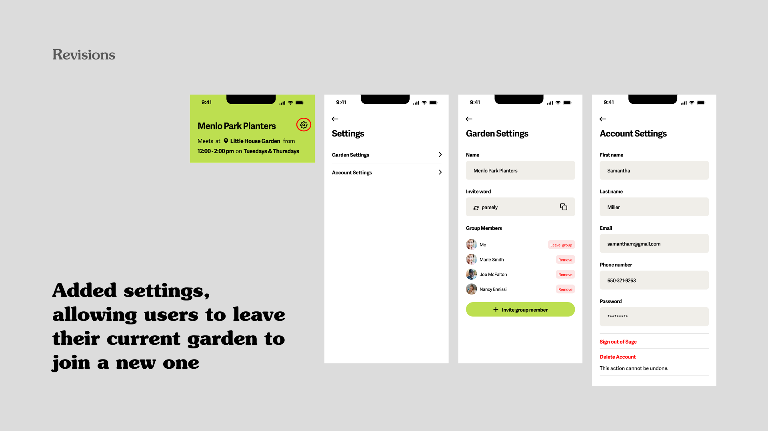

*Figure 17. Addressing Frustration with Multi-Group Creation and Joining*

The second critical issue we addressed was the limitation in group participation. Initially, our application restricted users from joining or creating new groups after their initial account setup. This restriction, though seemingly minor, significantly impacted the flexibility and control users had over their experience in the app. After careful consideration, we decided to focus on single-group participation for simplicity. However, we introduced a feature that allowed users to leave their current group. Accessible through the settings in the bottom navigation bar, this feature empowered users to join or create new groups as they desired, offering flexibility while maintaining a streamlined user experience.

Lastly, we tackled the limitations in the group creation process. Previously, users faced constraints in joining or creating multiple groups post-account creation. This limitation was a significant hurdle in fostering community engagement, which was one of our app's primary goals. To address this, we added the ability for users to leave a group, thus facilitating the option to join or create another group thereafter. This decision was made to concentrate on the quality of interaction within one group at a time, balancing community intimacy with user autonomy.

In summary, addressing these three severity 4 issues was a pivotal moment in our journey. It was not just about fixing problems but about refining the essence of our application. These changes were a testament to our commitment to delivering an app that was not only functional but also resonated with our users' needs and aspirations.

### Severity 3 Issues:

In refining our medium-fidelity prototype of Sage to address the severity 3 heuristic violations, we embarked on a journey of thoughtful redesign and strategic decision-making to enhance the app's usability and overall user experience.

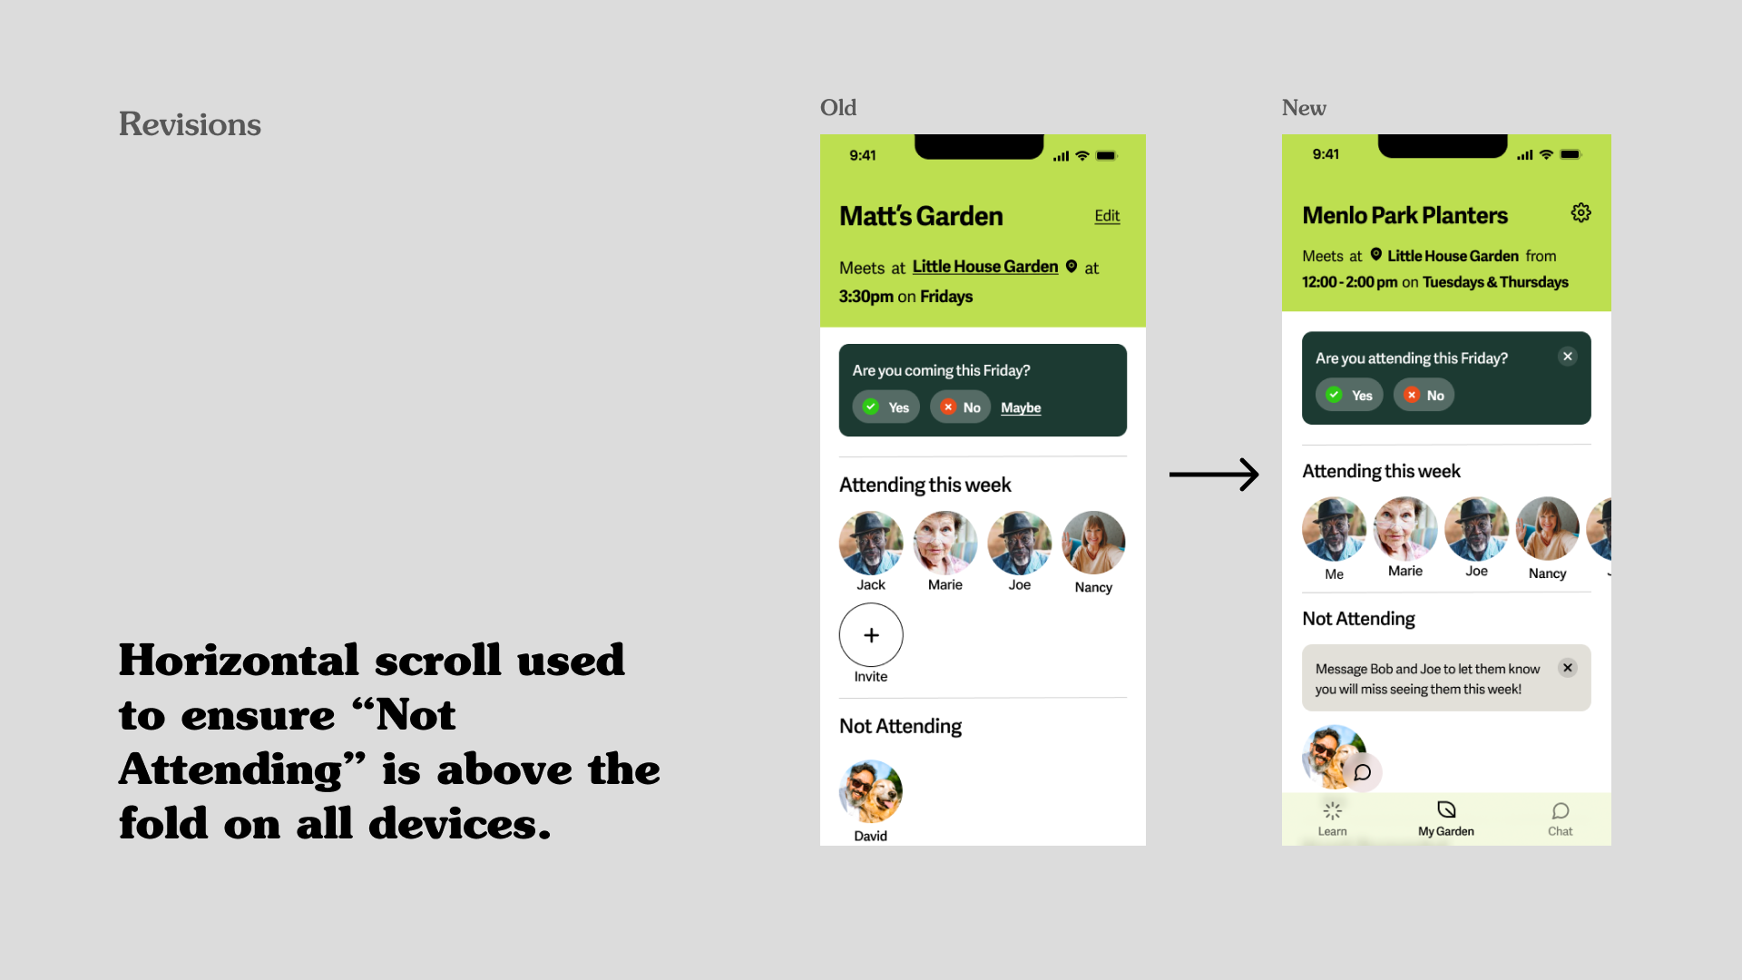

*Figure 18. Addressing Frustration with Multi-Group Creation and Joining*

We first tackled the visibility and accessibility of the "Not Attending" list in the attendees section. Originally tucked away below the fold, it was sometimes not immediately visible to users when there are too many group members, potentially leading to overlooking members who required attention. To remedy this, we implemented a horizontal scroll feature for the “Attending this Week” list. This design change ensured that the "Not Attending" list was prominently displayed above the fold on all devices, making it much easier for users to see and interact with members who might need a check-in.

Another significant enhancement was the integration of the device's native text and call features. Initially, the process of checking in on other group members was not as intuitive as we had hoped. By incorporating these native features, we simplified the check-in process, making it feel more natural and familiar to our users. To simplify the communication within the app further, we limited interactions to messaging and calling. This decision was in response to user confusion with other modes of communication, like Snapchat. We also addressed specific technical bugs that hindered the user experience, such as the inability to exit out of the text prompt in the invite group member task.

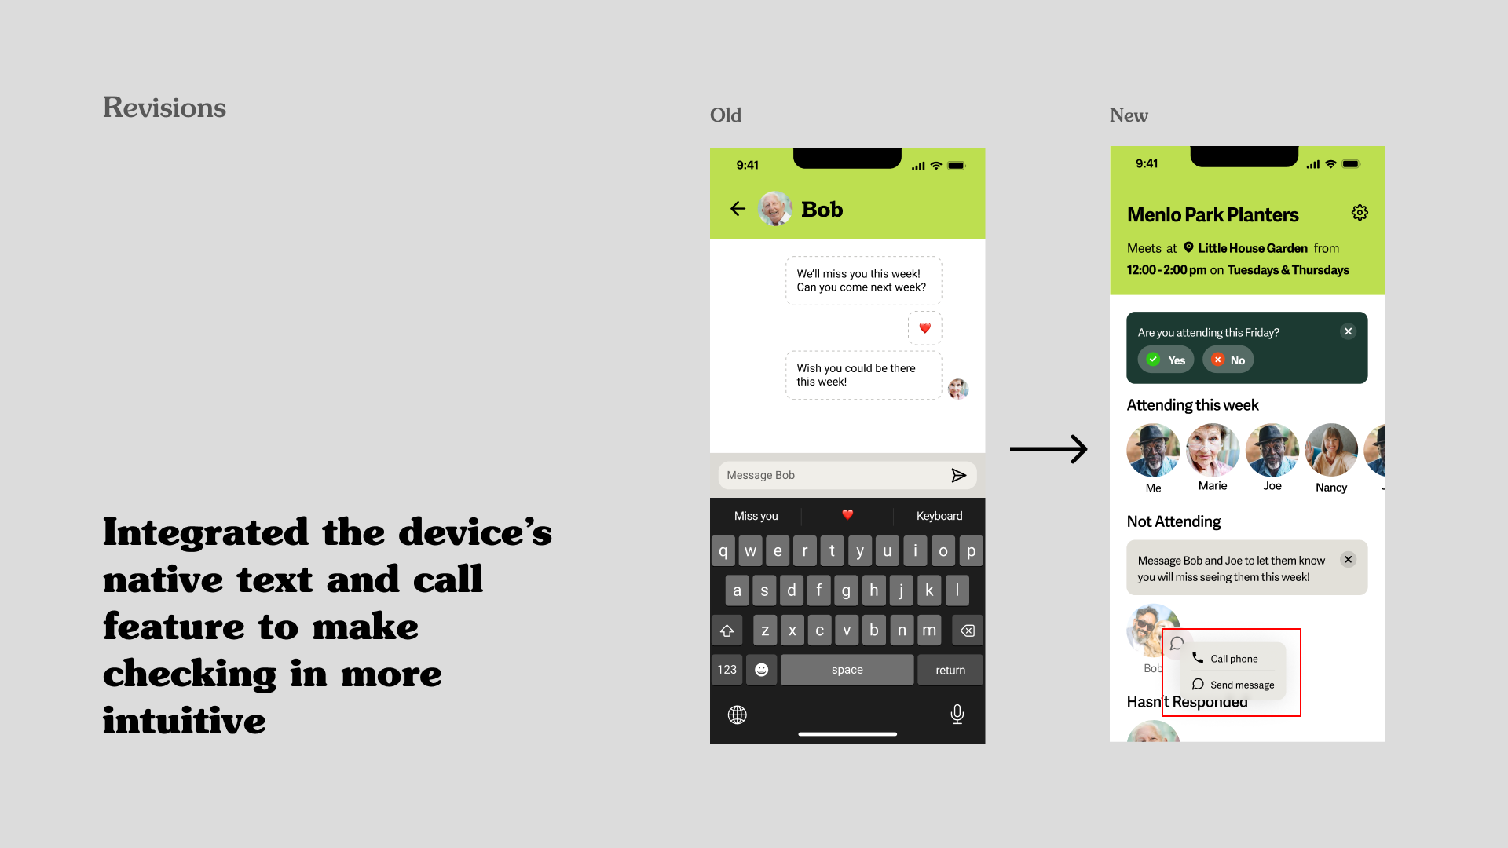

*Figure 19. Addressing Confusion with Communication*

The registration flow initially presented a challenge in terms of clarity and ease of use. In response, we separated the steps of this process, making each stage distinct and clear. This not only sped up the registration process but also significantly improved usability and clarity. Each step was designed to be self-explanatory, guiding the users through the process with minimal confusion.

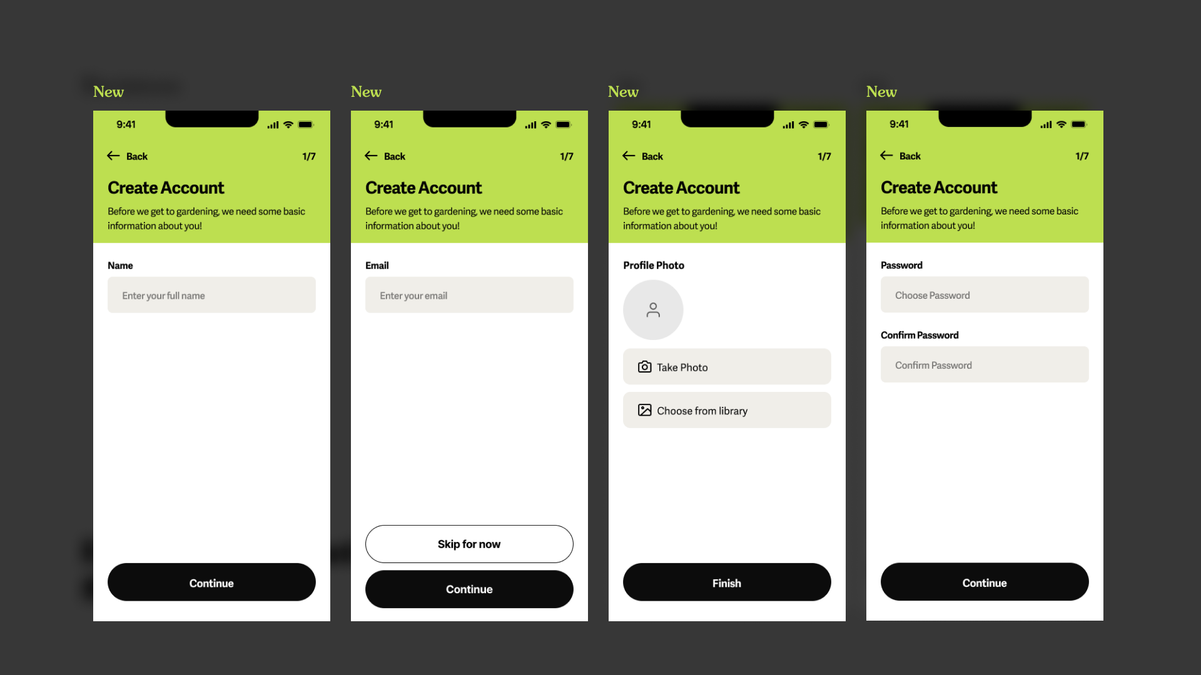

*Figure 20. Clarifying Registration through Separation*

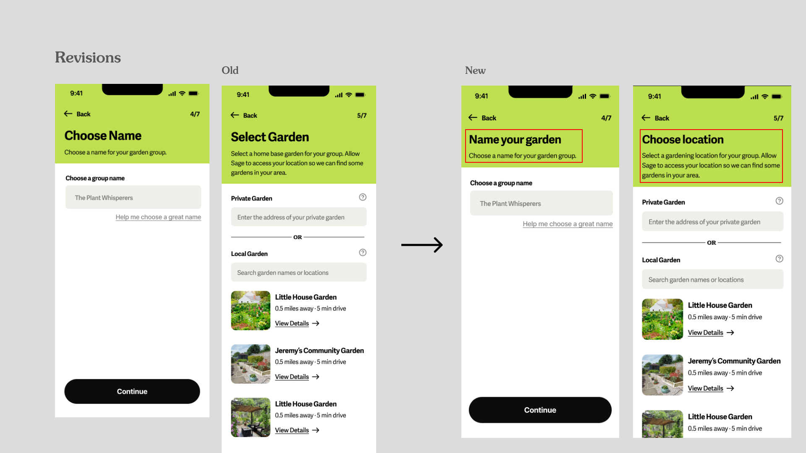

*Figure 21. Addressing Garden Creation and Selection Process*

In addressing the garden creation and selection process, we found that users were initially confused. To clarify this aspect of the app, we made edits to ensure that nearby gardens were displayed more clearly and that the location selection process was straightforward and explained in detail. This was done in a way that mirrored familiar user interfaces, making it faster and more user-friendly.

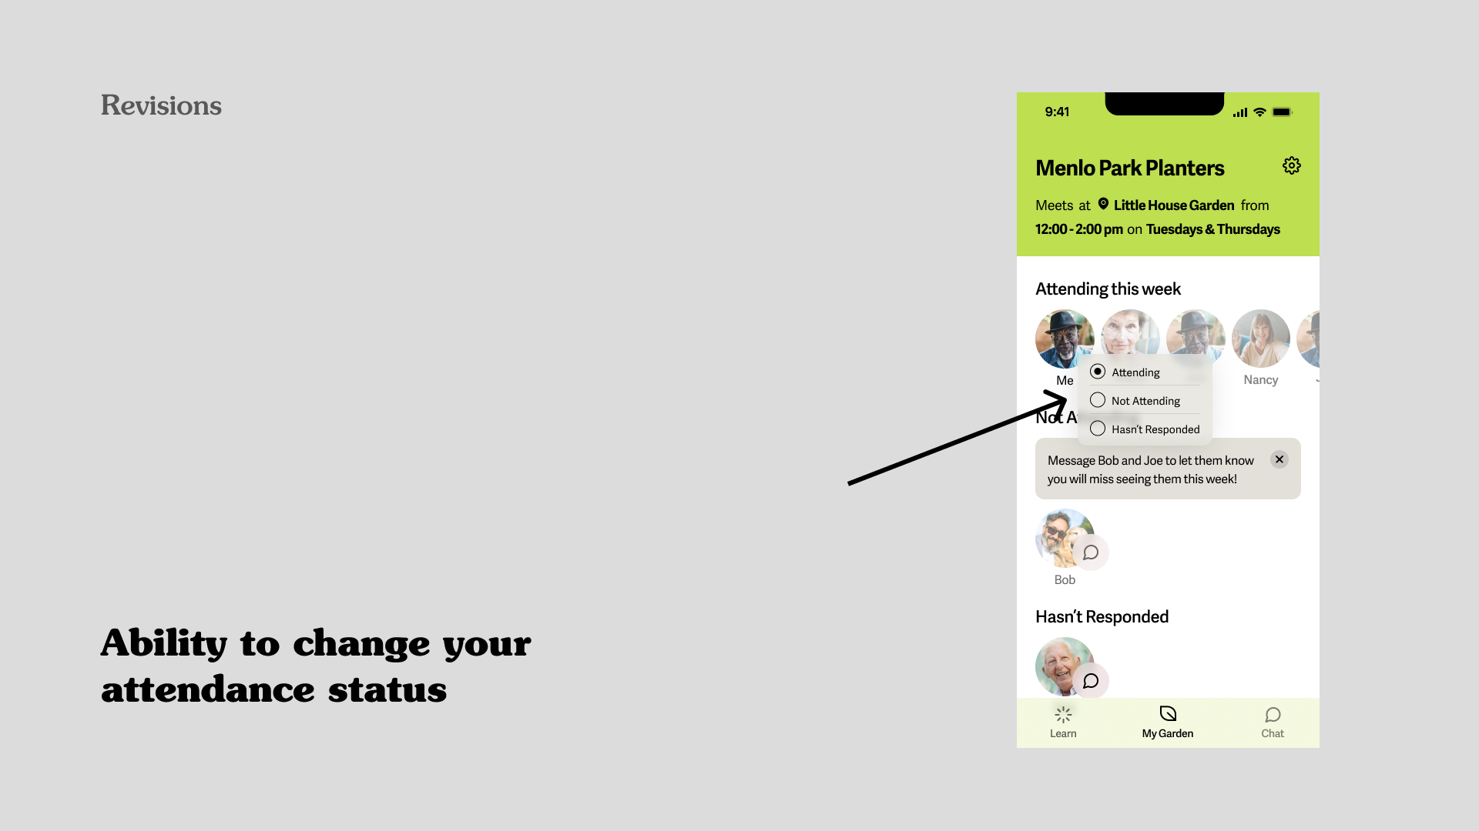

*Figure 22. Allow Users to Easily & Intuitively Change Attendance Status*

A key feature we introduced was the ability for users to easily change their attendance status. We realized that our users needed a simpler way to indicate whether they would attend a gardening session. To this end, we enabled users to update their status with a simple click on their profile picture, which was both intuitive and efficient.

During this redesign process, we also made some strategic decisions. Recognizing that our users valued familiarity, we decided not to overhaul the method of identifying user profiles despite there being feedback on not being able to identify oneself on certain pages. After careful consideration, we believed that our design was sufficient enough to convey this information to the user. Especially aftering implementing the dynamic capabilities of the High-Fi prototype where one can determine their name and upload a photo of themselves, we thought that self identification would be much clearer than with the hard-coded users we have in our Med-Fi prototype. However, we did make the conscious choice to position the user's profile picture first in line to comply with common design patterns. We also chose to focus on single garden membership for the initial implementation of our app as explained prior. This decision was made to maintain the intimacy and simplicity of the gardening groups. However, we added the ability in the settings for users to leave their current group, thus allowing them to join a new one while still focusing on the depth of experience in a single group at a time.

Lastly, after careful consideration and evaluating user feedback, we decided to remove the photo gallery feature from the app. While it was an interesting component, it did not resonate strongly with our users. Removing it allowed us to focus more on the core functionalities that were more valuable to our users and aligned better with the primary objectives of Sage.

Through these changes and strategic decisions, we not only addressed the identified heuristic violations but also enhanced the overall user experience, ensuring Sage remains a user-friendly and intuitive app for its target audience.

### Minor Changes for Usability Improvement:

1. Visual Consistency:

* Severity 2 - Inconsistent RSVP Button Styles (H4): Varied button aesthetics for RSVP options caused confusion.
* Change: Unified button design to maintain visual consistency and enhance user understanding.

1. Color Scheme Harmonization:

* Severity 1 - Clashing Color Palette (H8): Multiple green hues on the interface were visually discordant.
* Change: Harmonized color scheme for a cleaner, more accessible aesthetic.

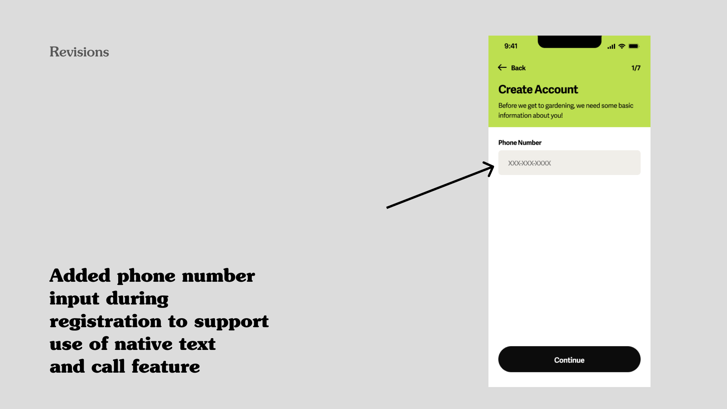

*Figure 23. Phone Number Collection During Registration*

1. Phone Number Input During Registration:

* Rationale: Supports the integrated text and call feature, crucial for seamless user interaction within the app.

### Additional Features Added:

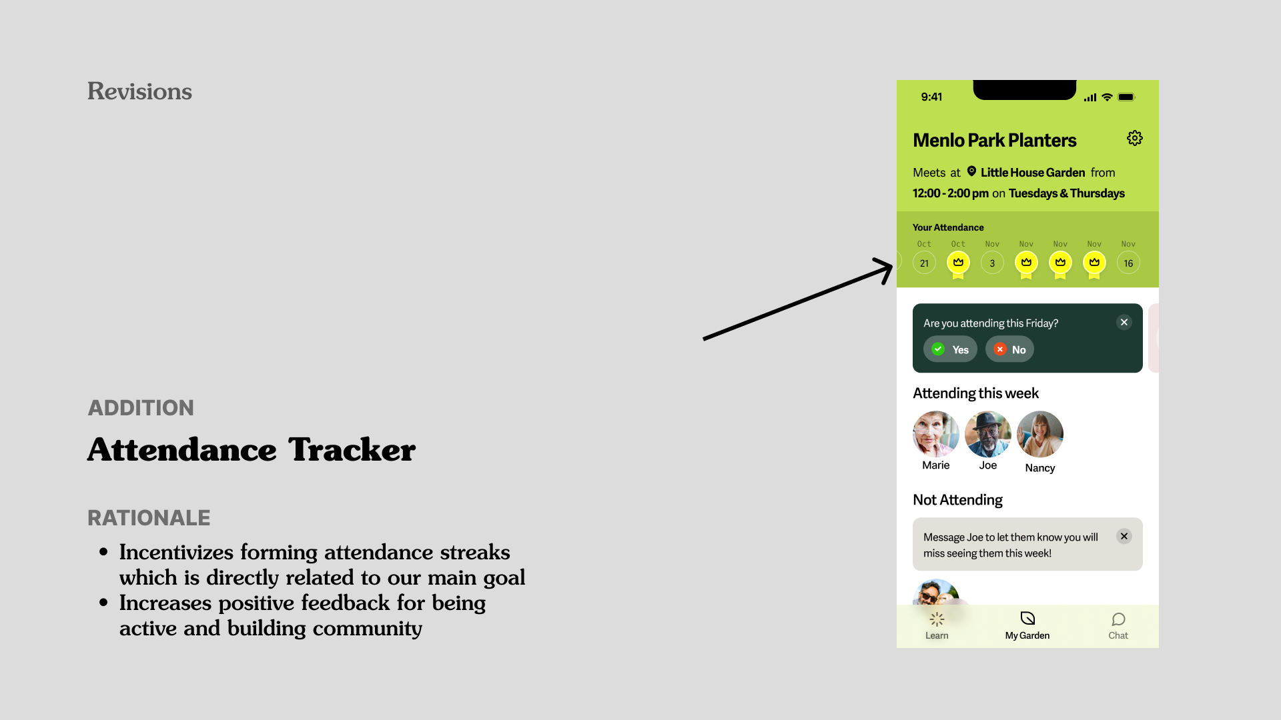

*Figure 24. Introducing Attendance Tracker Feature*

1. Attendance Tracker:

* Rationale: Encourages regular participation, fostering community engagement. This directly aligns with Sage’s objective to build and sustain active gardening communities.

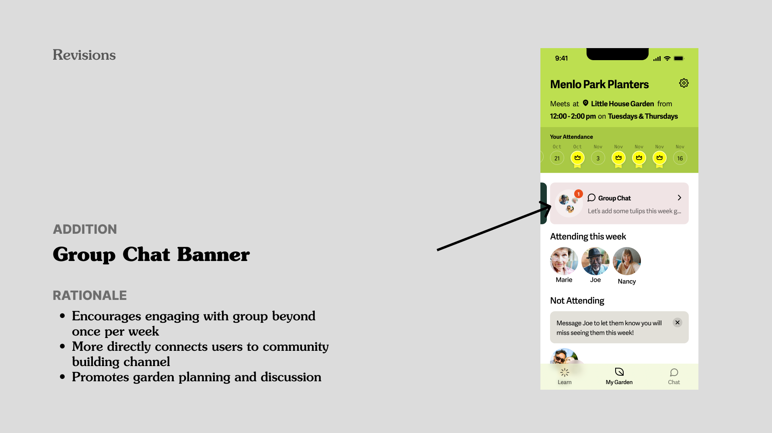

*Figure 25. Introducing Group Chat Banner Feature*

1. Group Chat Banner:

* Rationale: Facilitates ongoing communication, essential for community building. Encourages garden planning and discussion, thereby strengthening group cohesion.

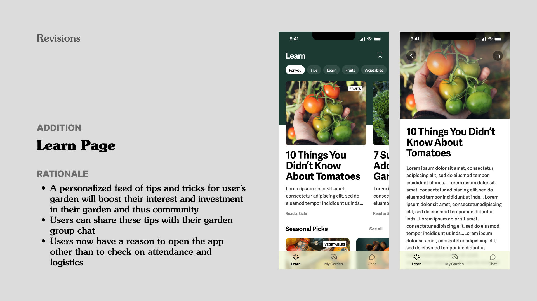

*Figure 26. Introducing Learn Page Feature*

1. Learn Page:

* Rationale: Provides personalized gardening tips, and encourages knowledge sharing within the community, aligning with the platform's educational and social values.

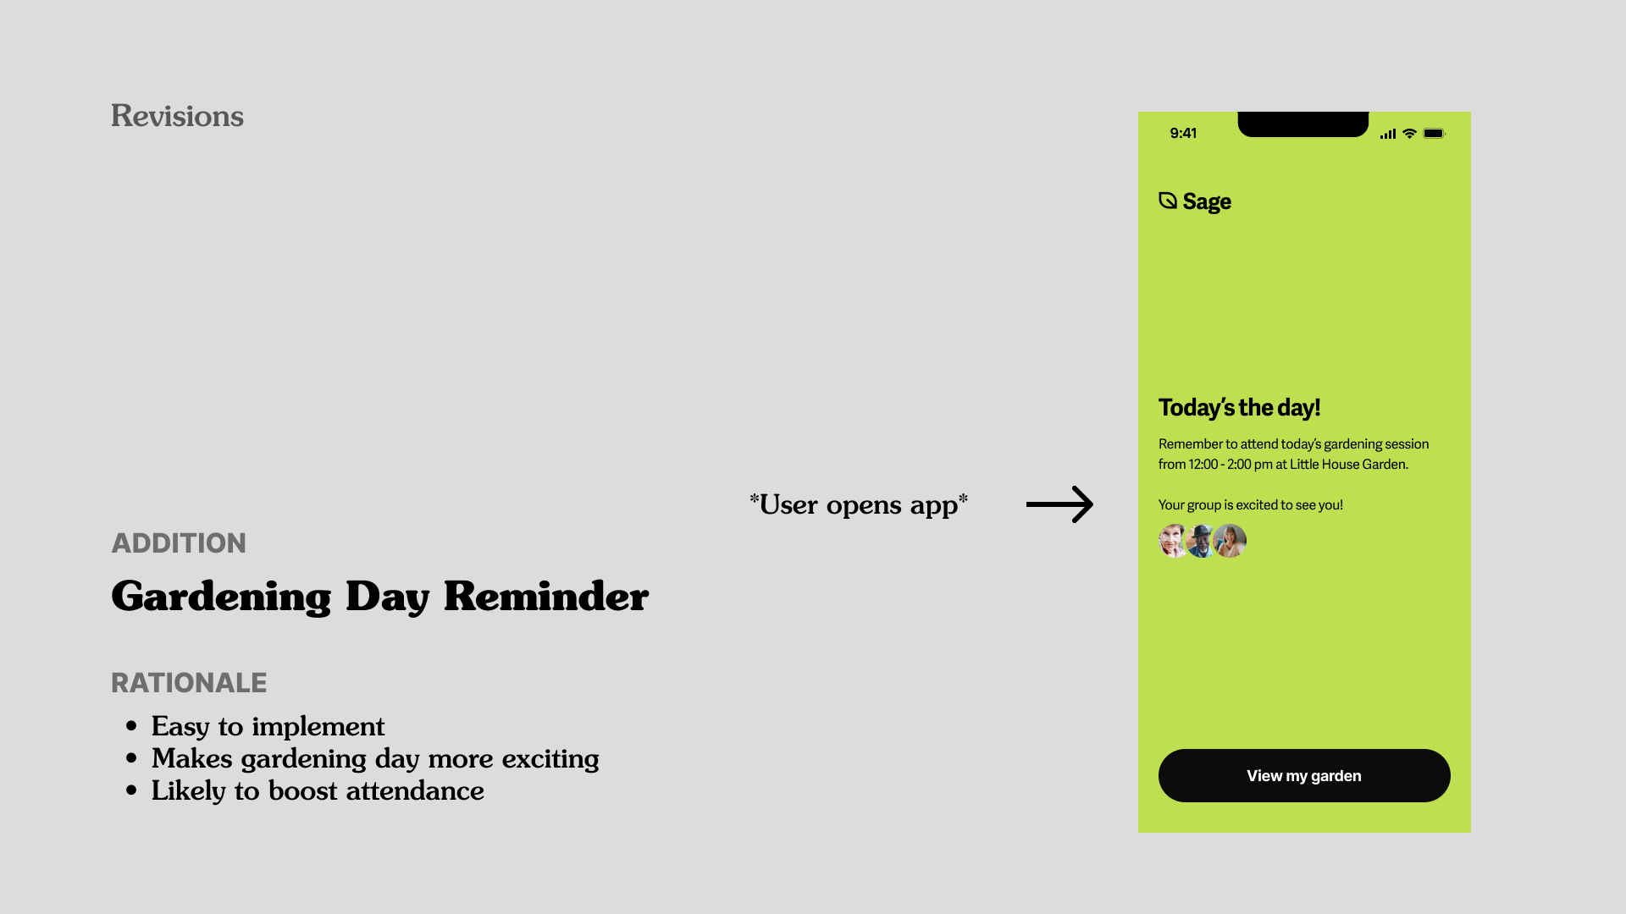

*Figure 27. Introducing Gardening Day Reminder Feature*

1. Gardening Day Reminder:

* Rationale: Builds excitement for gardening sessions. Directly contributes to the platform's goal of enhancing community interaction and participation.

These major revisions and additional features were meticulously designed to address user feedback, improve the overall user experience, and ensure the app's design aligns with its core values of community building, inclusivity, and user-friendly navigation. These enhancements reflected Sage's commitment to creating a platform that not only meets functional needs but also enriches the social and gardening experiences of its elderly user base.

# 

# 7. Values in Design

### 1. Community Focus: 'It's About People, Not Plants'

* At the core of Sage's design philosophy is the belief that the app should serve as a catalyst for community building, rather than just being a gardening tool. The interface and functionalities are geared towards encouraging social interactions, sharing experiences, and fostering a sense of unity among members. Features like group chats and events are carefully crafted to promote regular social gatherings, facilitating the formation of meaningful relationships beyond the scope of gardening.

### 2. Gentle Accountability

* Sage’s design subtly promotes accountability among its users, ensuring that they feel a sense of responsibility towards their gardening community. The attendance features are designed to be non-intrusive yet effective, allowing users to signal their participation in upcoming sessions. This feature supports the idea of commitment to the group while allowing flexibility, acknowledging that users might have varying levels of ability and availability.

### 3. Extreme Accessibility

* Understanding the unique needs of its elderly audience, Sage is meticulously designed for exceptional ease of use:
  + Larger Buttons: These are strategically sized and placed to accommodate users with reduced fine motor skills, ensuring comfortable interaction.
  + Higher Contrast: Visual elements are designed with high contrast to cater to users with diminished vision, ensuring that all information is easily discernible.
  + Full-Sentence Instructions: The app uses clear, concise language in full sentences to guide users through its features, making it easy for everyone to understand and use the app effectively.
  + Simplicity & Clarity: The user interface is streamlined to avoid overwhelming users with too many options or complex navigation paths.
  + Consideration for Blue and Green Confusion: The color scheme is chosen to be inclusive for those with color vision deficiencies, particularly keeping in mind common issues like blue-green color confusion.

### 4. Empowering the Elderly

* Sage is designed to empower its elderly users, giving them autonomy and control over their gardening activities and social interactions. The app allows users to take charge of organizing and managing their gardening groups, offering a sense of accomplishment and purpose. This empowerment extends to personalizing their experience on the app, making it more than just a utility but a personal and enriching experience.

### 5. Nurturing Personal Growth

* Sage not only facilitates gardening activities but also nurtures personal growth. The app’s educational section provides valuable gardening tips and tricks, enhancing users’ horticultural skills. This feature encourages users to engage more deeply with their gardening activities, fostering a sense of achievement and contributing to their overall well-being.

### 6. Respect and Privacy

* Respect for individual users and their privacy is a key value in Sage’s design. The app is crafted to encourage positive, respectful interactions, steering clear of features that might lead to negative experiences. Privacy is upheld by limiting the amount of personal information shared on the platform, ensuring that users feel safe and secure in their interactions within the community.

## Value Conflicts and Resolutions

### Respect vs. Consistency

* Sage carefully balances the need for consistent community participation with individual respect. The app does this by allowing users to express their availability and preferences in a way that is considerate of their personal boundaries and needs.

### Respect vs. Intentionality

* While Sage encourages users to be intentional about community engagement, it is done in a manner that respects the dignity and preferences of all members. The app avoids features that could be perceived as invasive or judgmental, instead focusing on positive, growth-oriented experiences.

Through these expanded descriptions of its core values, we hope to demonstrate a deeper understanding of our users' needs and aspirations. The app is not just a tool for organizing gardening activities; it's a platform that enriches the lives of its users by fostering community, respect, personal growth, and meaningful social interactions.

# 

# 8. Final Prototype Implementation

For our final high-fidelity prototype, we employed an array of tools and techniques to bring our design to life, ensuring it was both functional and user-friendly. Here's a breakdown of the tools and methods we used, along with their advantages, limitations, and the specific techniques applied.

### Tools Used

1. React Native

* Pros: React Native was chosen for its ability to create cross-platform mobile applications efficiently. Its component-based architecture made it easy to reuse code and streamline the development process.
* Cons: Despite its flexibility, React Native sometimes presented challenges in passing data between screens/components, which could have been easier with additional tools like Redux.

2. Figma

* Pros: Figma facilitated our wireframing and design process, offering a collaborative environment for real-time updates and visualizing design changes.
* Cons: While excellent for design, Figma's limitations were apparent in implementing dynamic features and complex interactions.

3. VSCode

* Pros: Visual Studio Code (VSCode) provided a robust and versatile text editor, supporting various programming languages and extensions, enhancing our coding efficiency.
* Cons: VSCode requires a certain level of expertise to fully leverage its extensive features and add-ons.

4. Firebase

* Pros: Firebase enabled seamless integration of backend services like authentication and storage, simplifying the management of user data and interactions.
* Cons: Its limitations were felt in areas like querying and manipulating data, which sometimes demanded more intricate workarounds.

5. Expo Go (including Router, Camera, Image Picker, SMS, Contacts)

* Pros: Expo Go offered an accessible development environment, allowing us to test our app on real devices easily and integrate native functionalities like camera access and contact picking.
* Cons: We faced constraints with Expo when it came to implementing certain custom functionalities that were beyond its standard offerings.

6. Validator.js and FontAwesome

* Pros: These tools enhanced the app's user interface and input validation, ensuring a better user experience and data integrity.
* Cons: Their functionality was limited to their predefined features, sometimes necessitating additional coding for more specific requirements.

### Wizard of Oz Techniques

* Pressable Components: Certain interactive elements in the app were designed to change focus or indicate an action but didn’t trigger any real backend process. This technique helped simulate functionalities that were not fully developed.
* Hackable Login: Our authentication process appeared functional, allowing users to create accounts and log in. However, it was designed to be easily bypassed, demonstrating the workflow without actual security enforcement.

### Hard-coded Techniques

* User Data Simulation: Since we didn’t have a real user base, all user-related data, including profiles and garden information, were pre-set within the app.
* Garden Availability: The variety of gardens available during the registration flow was hard-coded, representing potential choices without real-time availability or user contributions.
* Chat and Photo Features: Conversations and photo uploads in the app were simulated with pre-written texts and images, giving an impression of active user interaction.
* Learn Page Articles: The knowledge section of the app is pre-populated with a variety of different content either written by one of our team members or pulled from articles on the internet. This is done to simulate what this page might look like in a vibrant knowledge ecosystem with different users participating in knowledge sharing.

In summary, our final prototype is a composite of various advanced tools and creative techniques. While it effectively demonstrates the core functionalities and user experience of our app, it's important to note the simulated aspects, which would be replaced with dynamic, real-time interactions in a fully developed version of the app.

## 

## Final Designs

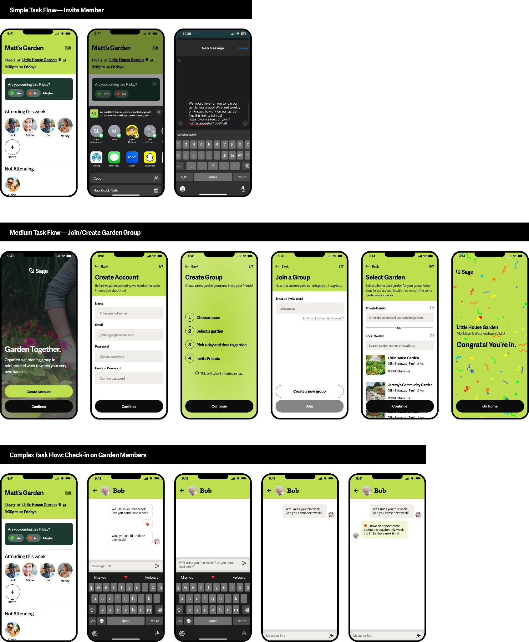

*Figure 28. Final Simple Task Flow Design*



*Figure 29. Final Medium Task Flow Design (Join a Group)*

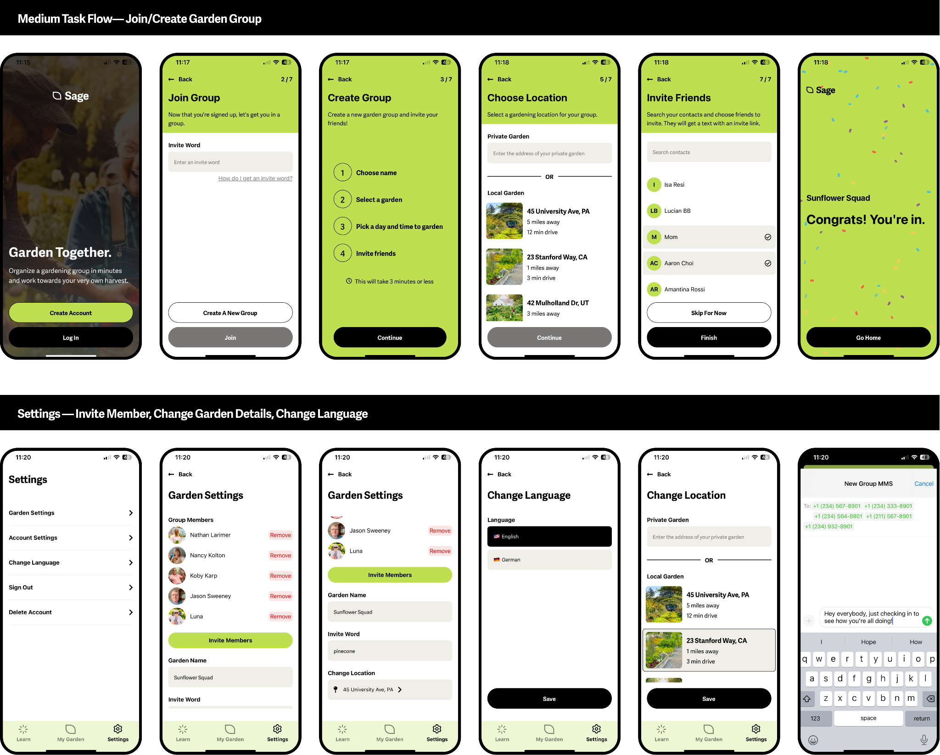

*Figure 30. Final Medium Task Flow Design (Create a Group)*



*Figure 31. Final Complex Task Flow Design*

*Figure 32. Final Settings Design*

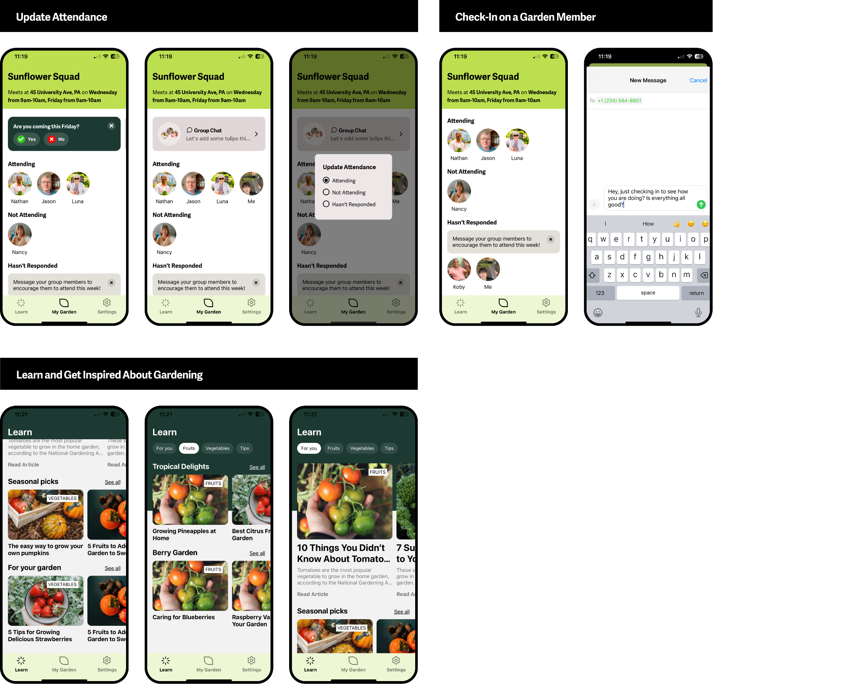

*Figure 33. Final Update Attendance Design*



*Figure 34. Final Learn Page Design*

# 

# 9. Reflection & Next Steps

## Reflections on the Design Thinking Process

Embracing Empathy Through Needfinding

* Deep Human Connections: Our journey began with an enriching needfinding process, where we formed deep connections with elderly individuals. The insights gained were more than data; they were stories and experiences that shaped our understanding and empathy.
* Heartfelt Interactions at Little House: The interactions at Little House community center were not just research opportunities; they were heartwarming experiences that significantly impacted our team. Their generosity and openness greatly influenced our design perspective.

Prototyping: A Path of Discovery

* Journey From Sketches to High-Fidelity: Our prototyping journey, from initial sketches to the high-fi prototype, was marked by continuous learning and adaptation. Each prototype phase was an exploration, fueled by the real-life stories and needs of our elderly users.
* Experience Prototyping and Usability Testing: These stages were more than technical evaluations. They were moments of human connection, where we saw our designs come to life and interact with real users, providing invaluable insights.

Design Exploration and Visual Storytelling

* Creative Exploration: Our design journey was marked by an exploration that transcended beyond screens and interfaces. It was about finding ways to tell stories, evoke emotions, and connect with our users on a deeper level.
* Visual Information Design as a Narrative Tool: We learned the power of visual design not just to inform but to engage and resonate. Our designs were more than layouts; they were visual narratives that reflected the lives and aspirations of our users.

Iterative Design: A Responsive and Human-Centric Approach

* Learning from Every Iteration: Each iterative step was a learning experience, enriched by the stories and feedback from our interactions. It wasn’t just about refining a product; it was about evolving with and for our users.
* From Feedback to Feature: Integrating feedback was more than a design process; it was about honoring the voices and experiences of our users. Each incorporated piece of feedback was a reflection of our commitment to our users’ needs and aspirations.

Insights from Studio Theme: Active Lifestyles

* Understanding Active Lifestyles Beyond Physicality: Our studio theme taught us that an active lifestyle is not just about physical activity; it's about social engagement, mental well-being, and a sense of belonging.
* Promoting Inclusivity and Accessibility: We learned the importance of designing for inclusivity, ensuring that our solutions cater to a diverse range of needs and abilities, fostering sustainable and enjoyable active lifestyles for all.

Personal Project Learnings: A Journey of Fulfillment

* Discovering Fulfillment in Design: In our quest to create an app that helps elderly individuals lead more fulfilling lives, we found fulfillment ourselves. The process of designing Sage became a source of joy and satisfaction for our team.
* Cherished Memories with the Little House Community: Our interactions at Little House were not just research sessions; they became cherished memories. The kindness and stories shared by these wonderful individuals enriched us personally and professionally.
* A Human Touch in Technology: This project reinforced the notion that technology, at its best, is a tool for enhancing human connections. It's about understanding, caring, and creating solutions that touch lives.

Given more time and resources, we aim to further humanize the Sage experience, perhaps by integrating more community-driven features or personal storytelling elements. For the time being, we have entertained some of the following:

1. Advanced Social Features

* Virtual Gardening Buddies: Introduce a feature that pairs users with virtual gardening buddies, fostering connections for those unable to physically attend.
* Shared Gardening Diaries: Implement a shared digital diary where group members can post updates, photos, and stories, enhancing the community bond.

2. Integrating Health and Wellness Tools

* Activity Trackers: Incorporate features that track physical activities like steps taken or time spent gardening, offering health insights tailored to the elderly.
* Wellness Workshops: Host virtual workshops on topics like healthy eating, gardening tips, and mental wellness, directly accessible through the app.

3. Gamification and Incentives

* Reward System: Develop a rewards system where users earn points for participation, which can be redeemed for gardening supplies or donations to charity.
* Gardening Challenges: Introduce monthly challenges with themes, encouraging users to try new gardening activities and share their achievements.

4. Accessibility Enhancements

* Voice Commands and Read-Aloud Features: Implement voice recognition for easier navigation and read-aloud options for users with visual impairments.
* Customizable Interface: Allow users to personalize the app’s interface, like text size and contrast, to cater to diverse visual needs.

5. Community Engagement and Partnerships

* Local Partnerships: Collaborate with local nurseries and gardening centers for workshops, discounts, and gardening events.
* Community Outreach Programs: Establish outreach initiatives to engage more members, particularly those who might feel isolated or disconnected.

6. Expansion of Gardening Knowledge Base

* Interactive Tutorials: Offer a library of interactive gardening tutorials, from beginner to advanced levels, catering to diverse interests and skills.
* Expert Q&A Sessions: Regular Q&A sessions with gardening experts, where users can get personalized advice and tips.

7. Advanced Analytics for Personalization

* Custom Garden Suggestions: Use machine learning to suggest garden plans based on user preferences, local climate, and seasonality.
* User Behavior Insights: Analyze user interaction data to provide personalized content and recommendations, enhancing user engagement.

8. Enhanced Communication Tools

* Group Video Calls: Facilitate group video calls for virtual gardening sessions or social gatherings, especially beneficial for those unable to leave their homes.
* Multilingual Support: Expand the app’s language options to cater to non-English speaking users, fostering inclusivity.

9. Sustainable Gardening Initiatives

* Eco-friendly Practices: Educate and encourage eco-friendly gardening practices, like composting and water conservation.
* Community Gardens Partnership: Collaborate with community gardens to offer dedicated spaces for Sage users, promoting physical activity and social interaction.

10. Long-term Impact Studies

* Impact Assessments: Conduct studies to assess the long-term impact of gardening on mental and physical health in elderly communities.
* Feedback Loops: Establish robust feedback mechanisms to continually improve the app based on user experiences and suggestions.

These implementations are designed to not only enhance the gardening experience but also to deepen community ties, promote health and wellness, and ensure that the app remains an engaging, inclusive, and valuable resource for the elderly community.

## 

## Final Remarks

As we conclude our journey with Sage, we extend our deepest gratitude to everyone who contributed to this meaningful project. This endeavor was more than just a design exercise; it was an exploration into how technology can enhance the lives of the elderly, fostering community and purpose through gardening.

We are particularly thankful to Matthew Jörke, our Course Assistant in CS 147, and James Landay, our professor, whose guidance and insights were invaluable in shaping our project's direction. Their expertise helped us navigate the complexities of design thinking and apply these principles effectively.

Our partnership with the Little House Community Center, especially with Mariella Macui, provided us with an authentic understanding of the challenges and aspirations of our target audience. Her support and the center’s openness in sharing their experiences were instrumental in grounding our design in real-world needs.

We are also grateful to our classmates who offered constructive feedback and shared their diverse perspectives throughout the process. Their critiques and suggestions significantly enriched our design approach and helped us refine our prototype.

A special thanks goes out to the individuals from the Little House Community Center and elsewhere who generously shared their time, stories, and feedback. Interacting with them was not just enlightening but truly fulfilling. Their enthusiasm and candid input brought a human touch to our design process, reminding us that at the heart of every technological solution are the people it serves.

As we move forward, we carry with us the lessons learned, the friendships formed, and the inspiration drawn from this experience. We hope that Sage will continue to evolve and serve as a testament to the power of empathetic design in creating meaningful solutions for real-world problems.

To see more details about our project's evolution, visit our [project page](https://web.stanford.edu/class/cs147/projects/DesigningforActiveLifestyles/Sage/) on the Stanford HCI course website, and for a hands-on experience with Sage, explore our final prototype.

Thank you once again to everyone involved. Your contributions have been the cornerstone of this project's success.